Labor Market Report
August

aArkadnsas Dwepartmsent
of Workforce Services

www.discover.arkansas.gov

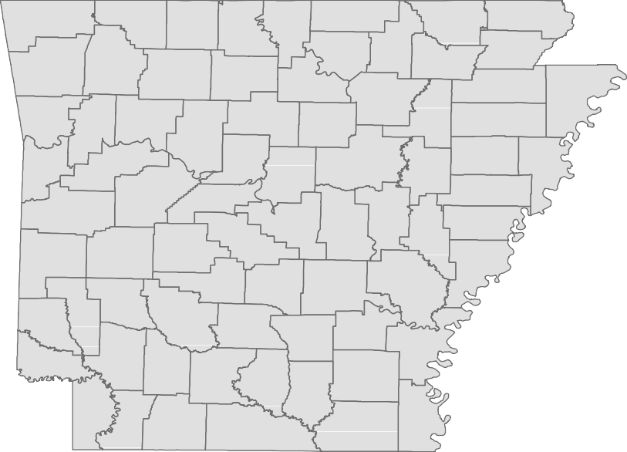
Table of Contents
Monthly Spotlight. 2
Arkansas Labor Force Summary. 3
Arkansas Nonfarm Payroll Jobs. 4
Arkansas Production Workers. 6
Metropolitan Statistical Areas. 7
Micropolitan Statistical Areas/Cities. 14
County Labor Force Statistics. 15
Local Workforce Development Areas. 18

August 2019

The Arkansas Labor Market is prepared monthly in conjunction with the U.S. Depart- ment of Labor, Bureau of Labor Statistics (BLS). The current month’s estimates are preliminary, while previous month’s data is subject to revision.
Estimates of nonfarm payroll jobs show the number of jobs by industry and reflect employment by place of work. Hours and earnings estimates are based on payroll and worker-hour data collected for production workers in manufacturing industries.
Industries are classified according to the North American Industry Classification System (NAICS). All estimates are based on a first quarter 2018 benchmark.

Explanation of Terms and Concepts Monthly Business Survey of Employers
A monthly sample survey designed to provide industry information on nonfarm payroll jobs. Data are compiled each month from mail surveys and telephone interviews conducted by the Bureau of Labor Statistics in cooperation with Department of Work- force Services. The data are based on es- tablishment records and include all workers, full-or part-time, who received pay during the payroll period which includes the 12th of

Technical Notes
the month. Approximately 5,000 Arkansas
business establishments are surveyed.

Metropolitan Statistical Area (MSA)
A term applied by the U.S. Office of Man- agement and Budget to counties that have one or more central cities and that meet specified criteria of population density, com- muting patterns and social and economic integration.

Current Population Survey (CPS)
A monthly sample survey of the popula- tion 16 years of age and over, designed to provide data on the labor force, the employed and the unemployed. The survey is conducted each month by the Bureau of the Census for BLS. The information is collected by trained interviewers from a sample of about 60,000 households. The data collected are based on the activity reported for the calendar week including the 12th of the month. Approximately 800 Arkansas households are represented in the sample survey.

Civilian Labor Force
The sum of all employed and unemployed persons 16 years of age or older. Members of the Armed Forces are excluded.

Employment
An estimate of the number of persons who worked any time for pay or profit or worked 15 hours or more as unpaid workers in a family business during the calendar week which includes the 12th of the month. Also included are those who, although not work- ing, had some job attachment and were not looking for work, and persons involved in labor management disputes.

Unemployment
An estimate of the number of persons who did not have a job, but were available for work and actively seeking work during the calendar week which includes the 12th of the month.

Unemployment Rate
The number of unemployed as a percentage of the civilian labor force. Unemployment rates are calculated from unrounded data.

Seasonal Adjustment
A statistical technique applied to monthly data to eliminate changes that normally oc- cur during the year due to seasonal events such as weather, major holidays, schedule shifts, harvest times, and the opening/clos- ing of schools.

August Spotlight
Seasonal Employment Trends (Part 2 of 2)

As discussed in the July Labor Market Report, employment in some major industry sectors is directly influenced by seasonal trends. When employment from multiple years is compared, these patterns become apparent. Seasonal trends are related to set schedules of operation, holidays, and weather patterns. Last month’s Spotlight discussed the seasonal trends seen in state and local government, educational services, and leisure and hospitality. In this issue, the seasonality of construction and professional-scientific-technical services are highlighted, along with some of the industries that are indirectly affected by seasonal movements.

Employment in the construction sector is sig- nificantly affected by weather patterns. While construction operations run year round, more

Chart 4. Jobs in Construction

January 2017 - August 2019
56,000

projects are commissioned during the spring
55,000

and summer than in the winter. In general, em- ployment in construction begins to increase in March, often peaking in September or October.

54,000

53,000

Employment then tends to decline after October
52,000

(see Chart 4). These weather patterns are a gen- eralization, as non-typical weather events will also influence jobs in construction. On the other hand, large scale projects can cause employment spikes that are unrelated to the weather.

Found under the professional and business ser- vices sector, the professional-scientific-technical

51,000

50,000

49,000

48,000

47,000

46,000

services subsector includes a particular type of
45,000

business that is highly seasonal-- accounting and tax preparation services. Seasonal hiring related
J F M A M J J A S O N D
2017 2018 2019

to tax preparation usually begins in November or December, with employment in the subsector peaking from February to April. Employment tends to remain fairly constant throughout the summer and fall months. While this seasonal trend is significant, employment in accounting and tax preparation is not large enough to affect the trend of the professional and business services sector as a whole.
August 2019

There are also other seasonal businesses, many of which may not be visible when tracking the movement of a major industry sector. For example, landscaping services is influenced by weather and the seasons. Employ- ment in landscaping services increases during the spring and summer months, but the number of workers is not large enough to impact the movement of the administrative and support services subsector as a whole. Similar- ly, employment in other services to buildings and dwellings (also under the administrative and support services subsector) tends to increase in the spring and summer. This includes activities such as cleaning swimming pools, driveways, and gutters and power-washing building exteriors.

It is important to keep in mind that some other industries are indirectly affected by these seasonal employment fluctuations. The timber industry, for example, relies heavily on the construction sector and may experience declines and increases in employment related to construction patterns. Similarly, movement within the retail trade sector will affect both wholesale trade and the transportation of goods. Some industries are indirectly affected by school closures in the summer. Employment in day care services (found under the social assistance subsector) increases in the summer when schools are closed, as does employment at businesses such as day camps and summer sports programs. There are also many non-profit organizations (under Other Services) with activities designed for children during the summer months.

State of Arkansas
Civilian Labor Force Summary

Labor force data, produced by the U.S. Department of Labor, Bureau of Labor Statistics and released by the Arkansas Division of Workforce Services, show Arkansas’ seasonally adjusted unemployment rate was unchanged at 3.4 percent between July and August. Arkansas’ civilian labor force declined 873, a result of 832 fewer employed and 41 fewer unemployed Arkansans. The United States’ jobless rate was also stable between July and August, remaining at 3.7 percent.
BLS Program Operations Manager Susan Price said, “Mirroring the trend seen at the national level, Ar- kansas’ unemployment rate remained stable in August. At 3.4 percent, the State maintains its lowest unemployment rate on record.”

Civilian Labor Force Estimates
Seasonally Adjusted
Not Seasonally Adjusted
Employment 1,315,649 1,316,481 1,301,386 Employment 1,310,876 1,327,070 1,303,679
Unemployment 46,865 46,906 49,101 Unemployment 48,726 54,577 48,951
Unemployment Rate 3.4 3.4 3.6 Unemployment Rate 3.6 4.0 3.6
U.S. Unemployment 3.7 3.7 3.8 U.S. Unemployment 3.8 4.0 3.9

 | Aug 19 | Jul 19 | Aug 18 | Aug 19 | Jul 19 | Aug 18
Civilian Labor Force | 1,362,514 | 1,363,387 | 1,350,487 Civilian Labor Force | 1,359,602 | 1,381,647 | 1,352,630

1,340,000

Number of Employed (Seasonally Adjusted)

August 2014 - August 2019

August 2019

1,320,000

1,300,000

1,280,000

1,260,000

1,240,000

1,220,000

1,200,000
Aug '14 Feb '15 Aug '15 Feb '16 Aug '16 Feb '17 Aug '17 Feb '18 Aug '18 Feb '19 Aug '19

 |  | August 2019
 | State of Arkansas
 | Not Seasonally Adjusted
 | (In Thousands)
(NAICS) | Aug 19 Jul 19 Aug 18 | OTM OTY
Total Nonfarm | 1269.7 1266.7 1254.9 | 3.0 14.8
Goods Producing | 224.2 223.2 218.4 | 1.0 5.8
Mining, Logging, and Construction | 60.1 60.4 57.6 | -0.3 2.5
Mining & Logging | 5.8 5.9 6.0 | -0.1 -0.2
Construction | 54.3 54.5 51.6 | -0.2 2.7
Specialty Trade Contractors | 33.4 33.7 32.8 | -0.3 0.6
Manufacturing | 164.1 162.8 160.8 | 1.3 3.3
Durable Goods | 78.4 77.6 76.5 | 0.8 1.9
Nondurable Goods | 85.7 85.2 84.3 | 0.5 1.4
Service Providing | 1045.5 1043.5 1036.5 | 2.0 9.0
Trade, Transportation & Utilities | 253.0 254.8 251.6 | -1.8 1.4
Wholesale Trade | 49.1 49.4 47.4 | -0.3 1.7
Retail Trade | 138.7 140.3 138.8 | -1.6 -0.1
Transport, Warehousing & Utilities | 65.2 65.1 65.4 | 0.1 -0.2
Information | 11.0 11.0 11.1 | 0.0 -0.1
Financial Activities | 63.4 62.9 61.2 | 0.5 2.2
Finance & Insurance | 49.0 48.6 47.3 | 0.4 1.7
Real Estate & Rental & Leasing | 14.4 14.3 13.9 | 0.1 0.5
Professional & Business Services | 144.5 145.6 145.7 | -1.1 -1.2
Professional, Scientific & Technical | 43.2 44.5 44.0 | -1.3 -0.8
Management of Companies | 36.3 35.9 34.7 | 0.4 1.6
Administrative & Support Services | 65.0 65.2 67.0 | -0.2 -2.0
Educational & Health Services | 191.5 189.0 189.6 | 2.5 1.9
Educational Services | 12.8 12.6 12.6 | 0.2 0.2
Health Care & Social Assistance | 178.7 176.4 177.0 | 2.3 1.7
Ambulatory Health Care | 59.3 59.1 58.6 | 0.2 0.7
Social Assistance | 40.6 39.2 39.9 | 1.4 0.7
Leisure & Hospitality | 125.5 127.4 122.1 | -1.9 3.4
Arts, Entertainment & Recreation | 12.6 13.1 12.7 | -0.5 -0.1
Accommodation & Food Services | 112.9 114.3 109.4 | -1.4 3.5
Accommodation Services | 11.8 12.2 11.9 | -0.4 -0.1
Food Services | 101.1 102.1 97.5 | -1.0 3.6
Other Services | 53.7 53.9 53.8 | -0.2 -0.1
Government | 202.9 198.9 201.4 | 4.0 1.5
Federal Government | 20.5 20.3 20.1 | 0.2 0.4
State Government | 74.7 72.9 74.3 | 1.8 0.4
Local Government | 107.7 105.7 107.0 | 2.0 0.7

Nonfarm Payroll Jobs

August 2019

State of Arkansas
Nonfarm Payroll Job Summary

July 2019 - August 2019
Nonfarm payroll jobs in Arkansas rose 3,000 in August to total 1,269,700. Gains were reported in four major industry sectors, more than offsetting declines in six sectors. The largest increase occurred in government (+4,000), as public schools and universities began the 2019-2020 school year. Educa- tional and health services added 2,500 jobs. Much of the expansion was in social assistance (+1,400), which includes education-related activities such as child and youth services, vocational rehabilitation, and day care centers. Jobs in manufacturing rose 1,300, with the largest gains in durable goods manu- facturing (+800). The greatest decrease occurred in leisure and hospitality (-1,900). The biggest loss was in food services (-1,000), due to reported contractions at limited service restaurants and snack bars. Notable declines were also posted in trade-transportation-utilities (-1,800) and in professional and
business services (-1,100).
August 2018 - August 2019
Compared to August 2018, Arkansas’ nonfarm payroll jobs are up 14,800. Seven major industry sec- tors added jobs, all increasing by 1,400 or more jobs, each. Employment in leisure and hospitality rose 3,400. All growth was in food services (+3,600). Jobs in manufacturing expanded 3,300, with reported hiring in both durable (+1,900) and nondurable (+1,400) goods manufacturing. Employment in construction is up 2,700, as large projects continue. Financial activities rose 2,200. A majority of the gains were reported in finance and insurance (+1,700). Educational and health services added 1,900 jobs, mostly in health care and social assistance (+1,700). Sizable growth also occurred in government (+1,500) and trade-transportation-utilities (+1,400). Professional and business services posted the largest decline (-1,200). Most of the loss was reported in administrative and support services (-2,000), a subsector which includes employment agencies.

Over-the-Year Employment Change by Industry Sector (Not Seasonally Adjusted)

August 2018 vs August 2019

Leisure & Hospitality

Manufacturing

Construction

Financial Activities

Educational & Health

Government

Trade-Transport-Utilities

Other Services

Information

Mining & Logging

Professional & Business

-2,000 -1,000 0 1,000 2,000 3,000 4,000

State of Arkansas
Production Workers- Hours and Earnings

Manufacturing
Aug 18
42.8
17.59
752.85
Jul 19
40.8
18.64
760.51
Aug 19
Average Weekly Hours 41.2
Average Hourly Earnings 18.50
Average Weekly Earnings 762.20

Durable Goods and Nondurable Goods Manufacturing
Aug 18
42.0
15.60
655.20
Jul 19
40.7
16.63
676.84
Aug 19
Average Weekly Hours 40.5
Average Hourly Earnings 16.70
Average Weekly Earnings 676.35
Aug 18
43.6
19.85
865.46
Jul 19
41.0
20.90
856.90
Aug 19
Average Weekly Hours 42.0
Average Hourly Earnings 20.47
Average Weekly Earnings 859.74
Nondurable Goods Manufacturing
Durable Goods Manufacturing

$25.00

Average Hourly Earnings- Durable Goods vs Nondurable Goods Manufacturing

August: 2009 - 2019

August 2019

$20.00

$15.00

$10.00

$5.00

$-
2009 2010 2011 2012 2013 2014 2015 2016 2017 2018 2019
Durable Goods Nondurable Goods

Metropolitan Statistical Areas
Little Rock-North Little Rock-Conway MSA

The Little Rock-North Little Rock-Conway MSA = Faulkner, Grant, Lonoke, Perry, Pulaski, & Saline counties.

Civilian Labor Force Estimates (Not Seasonally Adjusted)

 | Aug 19 | Jul 19 | Aug 18 | OTM | OTY
Civilian Labor Force | 357,838 | 366,962 | 357,677 | -9,124 | 161
Employment | 346,100 | 353,767 | 345,914 | -7,667 | 186
Unemployment | 11,738 | 13,195 | 11,763 | -1,457 | -25
Unemployment Rate | 3.3 | 3.6 | 3.3 | -0.3 | 0.0

Nonfarm Payroll Jobs (Not Seasonally Adjusted)
(In Thousands)

NAICS Aug 19 | Jul 19 | Aug 18 | OTM | OTY
Total Nonfarm 362.8 | 363.5 | 361.5 | -0.7 | 1.3
Goods Producing 38.4 | 38.3 | 38.4 | 0.1 | 0.0
Mining, Logging & Construction 17.3 | 17.2 | 17.4 | 0.1 | -0.1
Manufacturing 21.1 | 21.1 | 21.0 | 0.0 | 0.1
Service Providing 324.4 | 325.2 | 323.1 | -0.8 | 1.3
Trade, Transportation & Utilities 70.5 | 71.0 | 70.4 | -0.5 | 0.1
Wholesale Trade 16.4 | 16.4 | 15.9 | 0.0 | 0.5
Retail Trade 38.0 | 38.6 | 38.8 | -0.6 | -0.8
Trans., Warehousing & Utilities 16.1 | 16.0 | 15.7 | 0.1 | 0.4
Information 4.1 | 4.2 | 4.2 | -0.1 | -0.1
Financial Activities 21.7 | 21.7 | 21.4 | 0.0 | 0.3
Professional & Business Services 48.0 | 48.9 | 49.4 | -0.9 | -1.4
Educational & Health Services 58.1 | 58.2 | 57.0 | -0.1 | 1.1
Leisure & Hospitality 36.2 | 36.3 | 35.6 | -0.1 | 0.6
Other Services 16.2 | 16.3 | 15.9 | -0.1 | 0.3
Government 69.6 | 68.6 | 69.2 | 1.0 | 0.4
Federal Government 9.8 | 9.7 | 9.6 | 0.1 | 0.2
State Government 34.9 | 34.3 | 34.6 | 0.6 | 0.3
Local Government 24.9 | 24.6 | 25.0 | 0.3 | -0.1

Unemployment Rates

August: 2009 - 2019
8.0%

Nonfarm Payroll Jobs

January 2017 - August 2019
370,000

7.0%

365,000

6.0%

5.0% 360,000

4.0%

355,000

3.0%

2.0% 350,000

1.0%

August 2019

0.0%

'09 '10 '11 '12 '13 '14 '15 '16 '17 '18 '19

345,000 J F M A M J J A S O N D
2017 2018 2019

Metropolitan Statistical Areas
Fayetteville-Springdale-Rogers MSA

The Fayetteville-Springdale-Rogers MSA = Benton, Madison, & Washington counties in Arkansas
and McDonald county in Missouri.
Civilian Labor Force Estimates (Not Seasonally Adjusted)

 | Aug 19 | Jul 19 | Aug 18 | OTM | OTY
Civilian Labor Force | 282,163 | 286,734 | 274,988 | -4,571 | 7,175
Employment | 274,805 | 278,628 | 267,367 | -3,823 | 7,438
Unemployment | 7,358 | 8,106 | 7,621 | -748 | -263
Unemployment Rate | 2.6 | 2.8 | 2.8 | -0.2 | -0.2

Nonfarm Payroll Jobs (Not Seasonally Adjusted)
(In Thousands)

NAICS Aug 19 | Jul 19 | Aug 18 | OTM | OTY
Total Nonfarm 264.5 | 262.6 | 256.2 | 1.9 | 8.3
Goods Producing 43.0 | 42.9 | 41.5 | 0.1 | 1.5
Mining, Logging & Construction 12.3 | 12.5 | 11.8 | -0.2 | 0.5
Manufacturing 30.7 | 30.4 | 29.7 | 0.3 | 1.0
Service Providing 221.5 | 219.7 | 214.7 | 1.8 | 6.8
Trade, Transportation & Utilities 57.1 | 57.2 | 56.1 | -0.1 | 1.0
Wholesale Trade 12.6 | 12.5 | 12.2 | 0.1 | 0.4
Retail Trade 26.7 | 26.9 | 26.3 | -0.2 | 0.4
Trans., Warehousing & Utilities 17.8 | 17.8 | 17.6 | 0.0 | 0.2
Information 2.2 | 2.2 | 2.1 | 0.0 | 0.1
Financial Activities 8.6 | 8.6 | 8.3 | 0.0 | 0.3
Professional & Business Services 53.4 | 52.7 | 49.7 | 0.7 | 3.7
Educational & Health Services 29.7 | 29.2 | 28.6 | 0.5 | 1.1
Leisure & Hospitality 26.3 | 26.6 | 27.2 | -0.3 | -0.9
Other Services 9.5 | 9.5 | 9.2 | 0.0 | 0.3
Government 34.7 | 33.7 | 33.5 | 1.0 | 1.2
Federal Government 2.7 | 2.7 | 2.7 | 0.0 | 0.0
State Government 14.4 | 13.5 | 13.4 | 0.9 | 1.0
Local Government 17.6 | 17.5 | 17.4 | 0.1 | 0.2

Number of Employed

August 2016 - August 2019
285,000

Jobs in Service-Providing Industries

August: 1999 - 2019
250,000

280,000

275,000

200,000

150,000

100,000

50,000

Aug '16 Feb '17 Aug '17 Feb '18 Aug '18 Feb '19 Aug '19 0
August 2019
270,000
265,000
260,000
255,000
250,000
245,000
240,000

'99 '01 '03 '05 '07 '09 '11 '13 '15 '17 '19

Metropolitan Statistical Areas
Fort Smith MSA

The Fort Smith MSA = Crawford & Sebastian counties in Arkansas & LeFlore & Sequoyah counties in Oklahoma.

Civilian Labor Force Estimates (Not Seasonally Adjusted)

 | Aug 19 | Jul 19 | Aug 18 | OTM | OTY
Civilian Labor Force | 118,652 | 120,369 | 118,922 | -1,717 | -270
Employment | 114,220 | 115,679 | 114,584 | -1,459 | -364
Unemployment | 4,432 | 4,690 | 4,338 | -258 | 94
Unemployment Rate | 3.7 | 3.9 | 3.6 | -0.2 | 0.1

Nonfarm Payroll Jobs (Not Seasonally Adjusted)
(In Thousands)

NAICS Aug 19 | Jul 19 | Aug 18 | OTM | OTY
Total Nonfarm 112.0 | 111.5 | 112.5 | 0.5 | -0.5
Goods Producing 22.9 | 22.9 | 23.0 | 0.0 | -0.1
Mining, Logging & Construction 5.2 | 5.2 | 5.4 | 0.0 | -0.2
Manufacturing 17.7 | 17.7 | 17.6 | 0.0 | 0.1
Service Providing 89.1 | 88.6 | 89.5 | 0.5 | -0.4
Trade, Transportation & Utilities 22.8 | 23.0 | 23.1 | -0.2 | -0.3
Wholesale Trade 4.2 | 4.2 | 4.2 | 0.0 | 0.0
Retail Trade 12.2 | 12.3 | 12.4 | -0.1 | -0.2
Trans., Warehousing & Utilities 6.4 | 6.5 | 6.5 | -0.1 | -0.1
Information 1.1 | 1.2 | 1.2 | -0.1 | -0.1
Financial Activities 4.0 | 4.0 | 3.9 | 0.0 | 0.1
Professional & Business Services 12.7 | 13.1 | 13.1 | -0.4 | -0.4
Educational & Health Services 17.3 | 17.2 | 17.0 | 0.1 | 0.3
Leisure & Hospitality 9.7 | 9.8 | 9.6 | -0.1 | 0.1
Other Services 4.5 | 4.5 | 4.5 | 0.0 | 0.0
Government 17.0 | 15.8 | 17.1 | 1.2 | -0.1
Federal Government 1.3 | 1.3 | 1.3 | 0.0 | 0.0
State Government 2.9 | 2.9 | 2.9 | 0.0 | 0.0
Local Government 12.8 | 11.6 | 12.9 | 1.2 | -0.1

Number of Unemployed

August: 2009 - 2019
12,000

Jobs in Leisure and Hospitality

January 2017 - August 2019
10,200

10,000

10,000
9,800

8,000

9,600

9,400

6,000

9,200

9,000
4,000

8,800

2,000 8,600

August 2019

0
'09 '10 '11 '12 '13 '14 '15 '16 '17 '18 '19

8,400 J F M A M J J A S O N D
2017 2018 2019

Metropolitan Statistical Areas
Hot Springs MSA
The Hot Springs MSA = Garland County.

Civilian Labor Force Estimates (Not Seasonally Adjusted)

 | Aug 19 | Jul 19 | Aug 18 | OTM | OTY
Civilian Labor Force | 41,590 | 42,849 | 41,095 | -1,259 | 495
Employment | 40,024 | 41,091 | 39,486 | -1,067 | 538
Unemployment | 1,566 | 1,758 | 1,609 | -192 | -43
Unemployment Rate | 3.8 | 4.1 | 3.9 | -0.3 | -0.1

Nonfarm Payroll Jobs (Not Seasonally Adjusted)
(In Thousands)
NAICS
Total Nonfarm Goods Producing Service Providing Government

Aug 19 | Jul 19 | Aug 18 | OTM | OTY
39.5 | 39.6 | 38.8 | -0.1 | 0.7
4.5 | 4.5 | 4.5 | 0.0 | 0.0
35.0 | 35.1 | 34.3 | -0.1 | 0.7
4.3 | 4.0 | 4.3 | 0.3 | 0.0

42,000

Number of Employed

January 2017 - August 2019

41,000

40,000

39,000

38,000

37,000

36,000
August 2019

J F M A M J J A S O N D
2017 2018 2019

Metropolitan Statistical Areas
Jonesboro MSA

The Jonesboro MSA = Craighead & Poinsett counties.

Civilian Labor Force Estimates (Not Seasonally Adjusted)

 | Aug 19 | Jul 19 | Aug 18 | OTM | OTY
Civilian Labor Force | 65,353 | 66,655 | 64,535 | -1,302 | 818
Employment | 63,428 | 64,439 | 62,525 | -1,011 | 903
Unemployment | 1,925 | 2,216 | 2,010 | -291 | -85
Unemployment Rate | 2.9 | 3.3 | 3.1 | -0.4 | -0.2

Nonfarm Payroll Jobs (Not Seasonally Adjusted)
(In Thousands)
NAICS
Total Nonfarm Goods Producing Service Providing Government

Aug 19 | Jul 19 | Aug 18 | OTM | OTY
59.3 | 58.8 | 58.1 | 0.5 | 1.2
10.2 | 10.2 | 10.1 | 0.0 | 0.1
49.1 | 48.6 | 48.0 | 0.5 | 1.1
8.7 | 8.5 | 8.6 | 0.2 | 0.1

65,000

Nonfarm Payroll Jobs

August: 1999 - 2019

August 2019

60,000

55,000

50,000

45,000

40,000

35,000

30,000
'99 '00 '01 '02 '03 '04 '05 '06 '07 '08 '09 '10 '11 '12 '13 '14 '15 '16 '17 '18 '19

Metropolitan Statistical Areas
Pine Bluff MSA

The Pine Bluff MSA = Cleveland, Jefferson, & Lincoln counties.

Civilian Labor Force Estimates (Not Seasonally Adjusted)

 | Aug 19 | Jul 19 | Aug 18 | OTM | OTY
Civilian Labor Force | 35,024 | 35,899 | 35,430 | -875 | -406
Employment | 33,180 | 33,826 | 33,679 | -646 | -499
Unemployment | 1,844 | 2,073 | 1,751 | -229 | 93
Unemployment Rate | 5.3 | 5.8 | 4.9 | -0.5 | 0.4

Nonfarm Payroll Jobs (Not Seasonally Adjusted)
(In Thousands)
NAICS
Total Nonfarm Goods Producing Service Providing Government

Aug 19 | Jul 19 | Aug 18 | OTM | OTY
32.7 | 32.6 | 33.1 | 0.1 | -0.4
6.0 | 6.0 | 6.1 | 0.0 | -0.1
26.7 | 26.6 | 27.0 | 0.1 | -0.3
8.8 | 8.6 | 8.9 | 0.2 | -0.1

9.0%

Unemployment Rates

August 2014 - August 2019

August 2019

8.0%

7.0%

6.0%

5.0%

4.0%

3.0%

2.0%
Aug '14 Feb '15 Aug '15 Feb '16 Aug '16 Feb '17 Aug '17 Feb '18 Aug '18 Feb '19 Aug '19

Metropolitan Statistical Areas
Out-of-State MSA

Civilian Labor Force Estimates (Not Seasonally Adjusted)

Memphis, TN-MS-AR MSA

The Memphis, TN-MS-AR MSA = Fayette, Shelby, & Tipton counties in Tennessee; Benton, Desoto, Marshall, Tate, & Tunica counties in Mississippi; & Crittenden County in Arkansas.

 | Aug 19 | Jul 19 | Aug 18 | OTM | OTY
Civilian Labor Force | 650,601 | 664,902 | 630,762 | -14,301 | 19,839
Employment | 623,122 | 631,669 | 603,636 | -8,547 | 19,486
Unemployment | 27,479 | 33,233 | 27,126 | -5,754 | 353
Unemployment Rate | 4.2 | 5.0 | 4.3 | -0.8 | -0.1

Texarkana MSA
The Texarkana MSA= Bowie County in Texas & Little River & Miller counties in Arkansas.

 | Aug 19 | Jul 19 | Aug 18 | OTM | OTY
Civilian Labor Force | 64,226 | 64,768 | 63,938 | -542 | 288
Employment | 61,369 | 61,723 | 60,632 | -354 | 737
Unemployment | 2,857 | 3,045 | 3,306 | -188 | -449
Unemployment Rate | 4.4 | 4.7 | 5.2 | -0.3 | -0.8

Memphis MSA - Civilian Labor Force

January 2017 - August 2019
670,000

Texarkana MSA - Number of Unemployed

August: 2009 - 2019
6,000

660,000
5,000

650,000

640,000

4,000

630,000
3,000

620,000

2,000
610,000

600,000

1,000

August 2019
590,000 J F M A M J J A S O N D
2017 2018 2019

0
'09 '10 '11 '12 '13 '14 '15 '16 '17 '18 '19

Micropolitan Statistical Areas and Cities
Civilian Labor Force Estimates
Micropolitan Labor Force Estimates

3.8
4.1
5.4
4.4
5.3
4.8
3.4
5.6
3.8
4.7
3.7
4.0
3.2
4.6
4.0
359
649
941
533
844
402
635
360
503
423
509
653
638
1,693
1,356
9,022
15,319
16,498
11,549
15,109
8,007
18,320
6,124
12,764
8,497
13,426
15,749
19,119
35,059
32,281
August 2018
Emp Unemp Rate
CLF
9,381
15,968
17,439
12,082
15,953
8,409
18,955
6,484
13,267
8,920
13,935
16,402
19,757
36,752
33,637
5.1
4.5
6.9
5.1
5.9
5.7
3.5
6.6
4.5
5.6
4.3
4.0
4.0
5.2
4.9
490
738
1,225
626
934
471
671
427
610
494
600
641
807
1,917
1,623
9,120
15,561
16,560
11,589
14,843
7,784
18,480
6,012
12,877
8,339
13,482
15,584
19,587
34,974
31,666
Emp Unemp Rate
CLF
9,610
16,299
17,785
12,215
15,777
8,255
19,151
6,439
13,487
8,833
14,082
16,225
20,394
36,891
33,289
4.2
4.2
5.3
4.8
5.3
5.0
3.3
6.0
4.0
4.8
3.9
4.0
3.5
4.5
4.1
405
682
923
579
839
414
636
388
533
429
536
643
698
1,638
1,372
Not Seasonally Adjusted
July 2019

9,238
15,399
16,448
11,501
14,968
7,867
18,432
6,056
12,786
8,483
13,300
15,521
19,250
34,978
32,125
August 2019
Emp Unemp Rate
CLF
9,643
16,081
17,371
12,080
15,807
8,281
19,068
6,444
13,319
8,912
13,836
16,164
19,948
36,616
33,497
Micro Area
Arkadelphia Micro Batesville Micro Blytheville Micro Camden Micro
El Dorado Micro Forrest City Micro Harrison Micro
Helena-West Helena Micro Hope Micro
Magnolia Micro Malvern Micro Mountain Home Micro Paragould Micro Russellville Micro Searcy Micro

Arkadelphia Micro = Clark County Batesville Micro = Independence County Blytheville Micro = Mississippi County
Camden Micro = Calhoun & Ouachita counties
El Dorado Micro = Union County
Forrest City Micro = St. Francis County Harrison Micro = Boone & Newton counties Helena-West Helena Micro = Phillips County Hope Micro = Hempstead & Nevada counties Magnolia Micro = Columbia County
City Labor Force Statistics
Malvern Micro = Hot Spring County Mountain Home Micro = Baxter County Paragould Micro = Greene County Russellville Micro = Pope & Yell counties Searcy Micro = White County

Not Seasonally Adjusted

August 2019 July 2019 August 2018

City CLF Emp Unemp
Rate
CLF Emp Unemp
Rate
CLF Emp Unemp
Rate

Bella Vista Benton Bentonville Blytheville Cabot Conway
El Dorado Fayetteville Fort Smith Hot Springs Jacksonville Jonesboro Little Rock
North Little Rock Paragould
Pine Bluff Rogers Russellville Searcy Sherwood Springdale Texarkana, AR Van Buren West Memphis
12,476
17,336
26,790
6,002
12,065
33,761
6,896
48,643
39,262
14,858
11,868
38,649
98,275
30,000
12,536
16,653
36,155
13,099
10,219
16,100
39,970
13,563
10,328
10,801
12,088
16,801
26,139
5,563
11,671
32,756
6,466
47,347
37,923
14,202
11,331
37,548
94,946
28,927
12,056
15,537
35,255
12,598
9,819
15,588
38,985
12,972
9,988
10,261
388
535
651
439
394
1,005
430
1,296
1,339
656
537
1,101
3,329
1,073
480
1,116
900
501
400
512
985
591
340
540
3.1
3.1
2.4
7.3
3.3
3.0
6.2
2.7
3.4
4.4
4.5
2.8
3.4
3.6
3.8
6.7
2.5
3.8
3.9
3.2
2.5
4.4
3.3
5.0
12,671
17,721
27,195
6,168
12,397
34,613
6,924
49,456
39,993
15,319
12,221
39,407
100,680
30,769
12,828
17,062
36,725
13,230
10,173
16,492
40,639
13,897
10,533
11,070
12,255
17,167
26,500
5,601
11,952
33,500
6,412
48,022
38,530
14,580
11,576
38,116
96,997
29,552
12,268
15,811
35,742
12,575
9,679
15,925
39,539
13,214
10,158
10,452
416
554
695
567
445
1,113
512
1,434
1,463
739
645
1,291
3,683
1,217
560
1,251
983
655
494
567
1,100
683
375
618
3.3
3.1
2.6
9.2
3.6
3.2
7.4
2.9
3.7
4.8
5.3
3.3
3.7
4.0
4.4
7.3
2.7
5.0
4.9
3.4
2.7
4.9
3.6
5.6
12,211
17,308
26,099
5,955
12,061
33,822
6,990
47,379
39,525
14,668
11,817
38,151
98,274
29,971
12,389
16,783
35,257
13,188
10,280
16,040
38,964
13,576
10,421
10,642
11,764
16,788
25,437
5,580
11,679
32,742
6,527
46,079
38,169
14,011
11,322
36,992
94,869
28,904
11,974
15,763
34,309
12,618
9,867
15,575
37,941
12,845
10,059
10,169
447
520
662
375
382
1,080
463
1,300
1,356
657
495
1,159
3,405
1,067
415
1,020
948
570
413
465
1,023
731
362
473
3.7
3.0
2.5
6.3
3.2
3.2
6.6
2.7
3.4
4.5
4.2
3.0
3.5
3.6
3.3
6.1
2.7
4.3
4.0
2.9
2.6
5.4
3.5
4.4

August 2019

www.discover.arkansas.gov 14

County Labor Force Statistics
Civilian Labor Force Estimates
Not Seasonally Adjusted

August 2019 July 2019 August 2018

County CLF Emp Unemp
Rate
CLF Emp Unemp
Rate
CLF Emp Unemp
Rate

Arkansas Ashley Baxter Benton Boone Bradley Calhoun Carroll Chicot Clark Clay Cleburne Cleveland Columbia Conway
Craighead Crawford Crittenden Cross Dallas Desha Drew Faulkner Franklin Fulton Garland Grant Greene Hempstead Hot Spring Howard
Independence
Izard Jackson Jefferson Johnson Lafayette Lawrence Lee Lincoln Little River Logan Lonoke Madison Marion Miller
9,584
7,626
16,164
137,860
15,775
4,419
2,384
13,002
3,335
9,643
5,733
9,218
3,254
8,912
8,183
54,976
26,663
21,852
7,366
2,834
5,546
7,615
61,918
7,385
4,794
41,590
8,403
19,948
9,757
13,836
5,603
16,081
4,934
5,891
27,784
10,011
2,446
6,653
2,859
3,986
5,461
8,615
34,115
7,570
6,591
19,667
9,325
7,224
15,521
134,221
15,247
4,244
2,285
12,639
3,119
9,238
5,480
8,816
3,128
8,483
7,827
53,409
25,723
20,918
7,058
2,696
5,310
7,231
60,010
7,108
4,599
40,024
8,128
19,250
9,367
13,300
5,421
15,399
4,675
5,529
26,241
9,531
2,322
6,354
2,727
3,811
5,222
8,218
33,032
7,370
6,334
18,866
259
402
643
3,639
528
175
99
363
216
405
253
402
126
429
356
1,567
940
934
308
138
236
384
1,908
277
195
1,566
275
698
390
536
182
682
259
362
1,543
480
124
299
132
175
239
397
1,083
200
257
801
2.7
5.3
4.0
2.6
3.3
4.0
4.2
2.8
6.5
4.2
4.4
4.4
3.9
4.8
4.4
2.9
3.5
4.3
4.2
4.9
4.3
5.0
3.1
3.8
4.1
3.8
3.3
3.5
4.0
3.9
3.2
4.2
5.2
6.1
5.6
4.8
5.1
4.5
4.6
4.4
4.4
4.6
3.2
2.6
3.9
4.1
9,689
7,712
16,225
139,995
15,816
4,479
2,421
12,963
3,371
9,610
5,775
9,328
3,343
8,833
8,300
56,033
27,166
22,409
7,200
2,867
5,482
7,744
63,433
7,353
4,926
42,849
8,616
20,394
9,867
14,082
5,685
16,299
4,809
5,912
28,448
10,181
2,437
6,564
2,875
4,108
5,565
8,671
35,271
7,746
6,658
20,109
9,396
7,232
15,584
136,075
15,267
4,288
2,314
12,584
3,113
9,120
5,484
8,909
3,206
8,339
7,893
54,217
26,160
21,308
6,859
2,722
5,209
7,286
61,372
7,065
4,706
41,091
8,313
19,587
9,441
13,482
5,470
15,561
4,530
5,493
26,704
9,633
2,313
6,242
2,748
3,916
5,307
8,234
33,828
7,540
6,386
19,218
293
480
641
3,920
549
191
107
379
258
490
291
419
137
494
407
1,816
1,006
1,101
341
145
273
458
2,061
288
220
1,758
303
807
426
600
215
738
279
419
1,744
548
124
322
127
192
258
437
1,443
206
272
891
3.0
6.2
4.0
2.8
3.5
4.3
4.4
2.9
7.7
5.1
5.0
4.5
4.1
5.6
4.9
3.2
3.7
4.9
4.7
5.1
5.0
5.9
3.2
3.9
4.5
4.1
3.5
4.0
4.3
4.3
3.8
4.5
5.8
7.1
6.1
5.4
5.1
4.9
4.4
4.7
4.6
5.0
4.1
2.7
4.1
4.4
9,244
7,682
16,402
134,467
15,678
4,219
2,385
12,955
3,372
9,381
5,845
9,155
3,301
8,920
8,166
54,237
26,846
21,648
7,477
2,761
5,490
7,493
61,945
7,392
4,720
41,095
8,396
19,757
9,725
13,935
5,872
15,968
4,972
5,830
28,079
10,169
2,454
6,687
2,937
4,050
5,456
8,812
34,113
7,431
6,476
19,625
8,957
7,291
15,749
130,618
15,148
4,036
2,300
12,580
3,174
9,022
5,607
8,749
3,180
8,497
7,834
52,618
25,905
20,731
7,183
2,641
5,259
7,133
59,984
7,118
4,534
39,486
8,133
19,119
9,355
13,426
5,663
15,319
4,695
5,470
26,623
9,592
2,334
6,436
2,801
3,876
5,169
8,468
33,055
7,224
6,222
18,682
287
391
653
3,849
530
183
85
375
198
359
238
406
121
423
332
1,619
941
917
294
120
231
360
1,961
274
186
1,609
263
638
370
509
209
649
277
360
1,456
577
120
251
136
174
287
344
1,058
207
254
943
3.1
5.1
4.0
2.9
3.4
4.3
3.6
2.9
5.9
3.8
4.1
4.4
3.7
4.7
4.1
3.0
3.5
4.2
3.9
4.3
4.2
4.8
3.2
3.7
3.9
3.9
3.1
3.2
3.8
3.7
3.6
4.1
5.6
6.2
5.2
5.7
4.9
3.8
4.6
4.3
5.3
3.9
3.1
2.8
3.9
4.8

August 2019
(continued on Page 16)

County Labor Force Statistics
Civilian Labor Force Estimates
(continued from Page 15)

Not Seasonally Adjusted

August 2019 July 2019 August 2018

County CLF Emp Unemp
Rate
CLF Emp Unemp
Rate
CLF Emp Unemp
Rate

Mississippi Monroe Montgomery Nevada Newton Ouachita Perry
Phillips Pike Poinsett Polk Pope Prairie Pulaski Randolph
St. Francis Saline Scott Searcy Sebastian Sevier Sharp Stone Union Van Buren
Washington White Woodruff Yell
17,371
2,795
3,007
3,562
3,293
9,696
4,278
6,444
4,339
10,377
8,100
28,328
3,564
190,969
7,312
8,281
58,155
4,288
2,955
56,607
5,453
5,692
4,937
15,807
5,646
125,902
33,497
2,814
8,288
16,448
2,683
2,869
3,419
3,185
9,216
4,102
6,056
4,170
10,019
7,749
27,032
3,427
184,369
7,043
7,867
56,459
4,141
2,806
54,682
5,167
5,412
4,750
14,968
5,368
122,746
32,125
2,666
7,946
923
112
138
143
108
480
176
388
169
358
351
1,296
137
6,600
269
414
1,696
147
149
1,925
286
280
187
839
278
3,156
1,372
148
342
5.3
4.0
4.6
4.0
3.3
5.0
4.1
6.0
3.9
3.4
4.3
4.6
3.8
3.5
3.7
5.0
2.9
3.4
5.0
3.4
5.2
4.9
3.8
5.3
4.9
2.5
4.1
5.3
4.1
17,785
2,811
3,058
3,620
3,335
9,794
4,405
6,439
4,281
10,622
8,018
28,513
3,608
195,719
7,319
8,255
59,518
4,368
2,807
57,627
5,517
5,813
4,943
15,777
5,668
127,998
33,289
2,741
8,378
16,560
2,666
2,913
3,436
3,213
9,275
4,212
6,012
4,094
10,222
7,665
26,984
3,412
188,351
6,999
7,784
57,691
4,202
2,668
55,557
5,224
5,506
4,724
14,843
5,368
124,496
31,666
2,592
7,990
1,225
145
145
184
122
519
193
427
187
400
353
1,529
196
7,368
320
471
1,827
166
139
2,070
293
307
219
934
300
3,502
1,623
149
388
6.9
5.2
4.7
5.1
3.7
5.3
4.4
6.6
4.4
3.8
4.4
5.4
5.4
3.8
4.4
5.7
3.1
3.8
5.0
3.6
5.3
5.3
4.4
5.9
5.3
2.7
4.9
5.4
4.6
17,439
2,786
3,045
3,542
3,277
9,697
4,272
6,484
4,329
10,298
8,072
28,419
3,599
190,752
7,169
8,409
58,199
4,323
3,043
56,979
5,588
5,660
4,912
15,953
5,854
122,690
33,637
2,847
8,333
16,498
2,674
2,909
3,409
3,172
9,249
4,106
6,124
4,157
9,907
7,741
27,076
3,471
184,220
6,899
8,007
56,416
4,159
2,925
55,037
5,322
5,386
4,710
15,109
5,554
119,458
32,281
2,722
7,983
941
112
136
133
105
448
166
360
172
391
331
1,343
128
6,532
270
402
1,783
164
118
1,942
266
274
202
844
300
3,232
1,356
125
350
5.4
4.0
4.5
3.8
3.2
4.6
3.9
5.6
4.0
3.8
4.1
4.7
3.6
3.4
3.8
4.8
3.1
3.8
3.9
3.4
4.8
4.8
4.1
5.3
5.1
2.6
4.0
4.4
4.2

August 2019

County Labor Force Summary

Between July and August, unemployment rates declined in 71 of Arkansas’ 75 counties. Three counties were unchanged, while one-- Lee County-- rose slightly over-the-month. Jobless rates ranged from a low of 2.5 percent in Washington County to a high of 6.5 percent in Chicot County.
In August, thirty-three counties posted unemployment rates at or below four percent. That is up from 20 counties last month. No county had a unemployment rate above seven percent, down from two counties at or above seven percent in July.
Compared to August 2018, jobless rates are up in 41 Arkansas counties. Twenty-six counties posted over-the-year rate declines, while 8 counties were the same as last year.

www.discover.arkansas.gov
17
Rate
4.5
4.6
4.6
4.6
4.6
4.8
4.8
4.9
4.9
4.9
5.0
5.0
5.0
5.0
5.1
5.2
5.2
5.3
5.3
5.3
5.3
5.6
6.0
6.1
6.5
Rank County
- Lawrence
- Lee
52 Logan
52 Montgomery
52 Pope
56 Columbia
56 Johnson
58 Dallas
58 Sharp
58 Van Buren
61 Drew
61 Ouachita
61 St. Francis
61 Searcy
- Lafayette
- Izard
66 Sevier
68 Ashley
68 Mississippi
68 Union
68 Woodruff
- Jefferson
- Phillips
- Jackson
- Chicot
Rank County Rate
25 Hot Spring 3.9
25 Marion 3.9
25 Pike 3.9
29 Baxter 4.0
29 Bradley 4.0
29 Hempstead 4.0
29 Monroe 4.0
29 Nevada 4.0
34 Fulton 4.1
34 Miller 4.1
34 Perry 4.1
34 White 4.1
34 Yell 4.1
39 Calhoun 4.2
39 Clark 4.2
39 Cross 4.2
39 Independence 4.2
43 Crittenden 4.3
43 Desha 4.3
43 Polk 4.3
46 Clay 4.4
46 Cleburne 4.4
46 Conway 4.4
46 Lincoln 4.4
46 Little River 4.4
Rate
2.5
2.6
2.6
2.7
2.8
2.9
2.9
3.1
3.2
3.2
3.3
3.3
3.3
3.4
3.4
3.4
3.5
3.5
3.5
3.7
3.8
3.8
3.8
3.8
3.9
Rank County
- Washington
- Benton
2 Madison
- Arkansas
- Carroll
- Craighead
6 Saline
- Faulkner
- Howard
9 Lonoke
11 Boone
11 Grant
11 Newton
14 Poinsett
14 Scott
14 Sebastian
17 Crawford
17 Greene
17 Pulaski
- Randolph
- Franklin
21 Garland
21 Prairie
21 Stone
25 Cleveland
August 2019

County Unemployment Rates
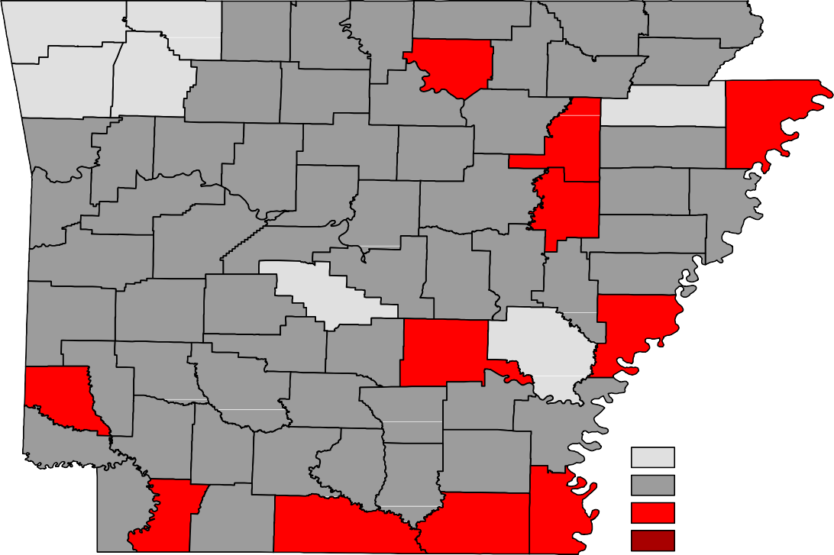
Benton
Carroll
Boone
Fulton
Clay
Marion
Baxter
Randolph
Sharp
Washington
Madison
Izard
Greene
Lawrence
Newton
Searcy
Stone
Independence
Craighead Mississippi
Crawford
Franklin
Johnson
Van Buren
Cleburne
Jackson Poinsett
Pope
Sebastian
Logan
Conway
White
Cross
Faulkner
Woodruff
Crittenden
Yell
Perry
St. Francis
Scott
Pulaski
Lonoke
Prairie
Lee
Saline
Monroe
Polk
Montgomery
Garland
Phillips
Howard
Hot Spring Grant
Jefferson
Arkansas
Pike
Sevier
Clark
Dallas
Cleveland
Lincoln
Desha
Little River Hempstead Nevada
Ouachita
Calhoun
Drew
Bradley
Miller Lafayette Columbia
Chicot
Union
Ashley
Unemployment Rates
< or = 3.0% 3.1% - 5.0%
5.1% - 7.0%
> 7.0% [NONE]
Ranked by Unemployment Rates
August 2019 (Not Seasonally Adjusted)

Local Workforce Development Areas
Civilian Labor Force Estimates
253,120 244,951 8,169 3.2
98,274 94,869 3,405 3.5
46,955 44,846 2,109 4.5
93,555 89,420 4,135 4.4
121,432 117,084 4,348 3.6
322,419 313,096 9,323 2.9
81,326 77,662 3,664 4.5
91,978 87,730 4,248 4.6
131,144 125,591 5,553 4.2
112,424 108,428 3,996 3.6
259,680 250,323 9,357 3.6
100,680 96,997 3,683 3.7
47,178 44,711 2,467 5.2
93,728 89,055 4,673 5.0
124,492 119,311 5,181 4.2
333,543 323,813 9,730 2.9
82,992 78,663 4,329 5.2
92,492 87,902 4,590 5.0
133,657 127,412 6,245 4.7
113,203 108,883 4,320 3.8
8,207 3.2
3,329 3.4
2,176 4.6
4,165 4.5
4,367 3.6
9,043 2.7
3,791 4.6
4,150 4.5
5,464 4.2
4,037 3.6
Eastern 46,802 44,626
North Central 93,504 89,339
Northeast 122,370 118,003
Northwest 329,112 320,069
Southeast 81,552 77,761
Southwest 91,582 87,432
West Central 131,503 126,039
Western 111,658 107,621
Central (minus LR) 253,241 245,034
City of Little Rock 98,275 94,946
August 2018
CLF Emp Unemp Rate
Emp Unemp Rate
CLF
Not Seasonally Adjusted
July 2019
August 2019
Emp Unemp Rate
CLF
LWDA

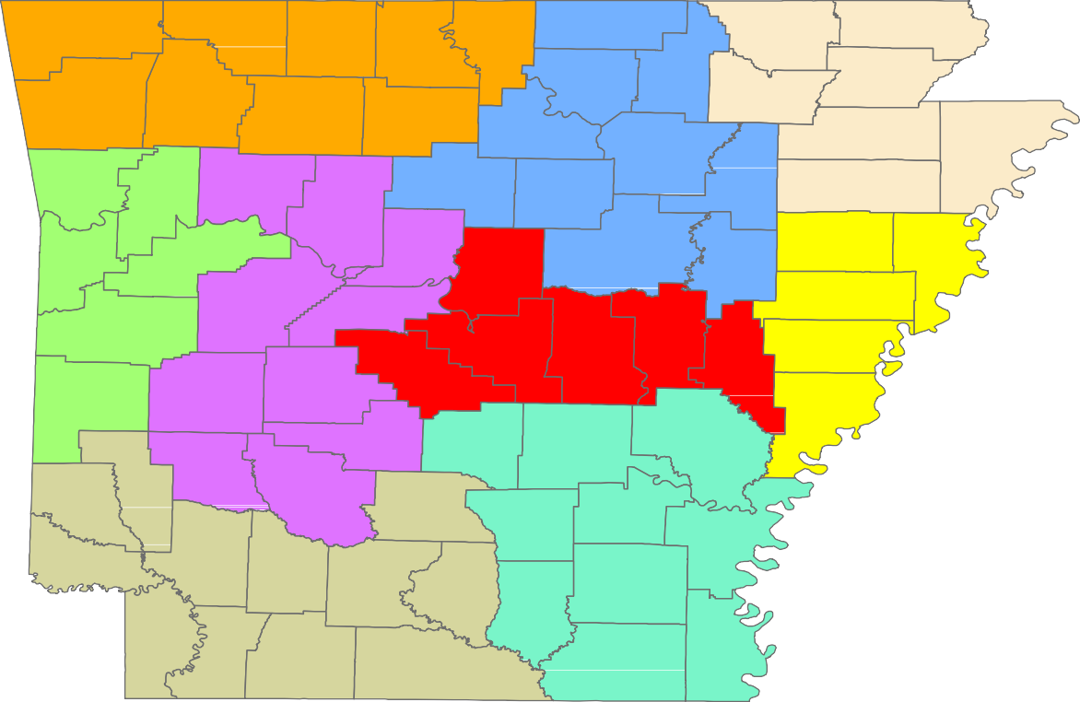
Benton
Carroll
Boone
Fulton
Clay
Marion
Baxter
Randolph
Sharp
Greene
Washington
Madison
Izard
Lawrence
Newton
Searcy
Stone
Craighead
Independence
Mississippi
Crawford
Franklin
Johnson
Van Buren
Cleburne
Jackson
Poinsett
Pope
Sebastian
Logan
Conway
White
Cross
Faulkner
Woodruff
Crittenden
Yell
Perry
St. Francis
Scott
Prairie
Pulaski Lonoke
Lee
Saline
Monroe
Polk
Montgomery
Garland
Phillips
Hot Spring
Grant
Jefferson
Arkansas
Howard
Pike
Sevier
Clark
Dallas
Cleveland
Lincoln
Desha
Little River Hempstead
Nevada
Ouachita
Calhoun
Drew
Bradley
Miller
Columbia
Chicot
Union
Ashley
Lafayette

Central (minus LR) Eastern
August 2019
www.discover.arkansas.gov
18
North Central
Northeast Northwest Southeast
Southwest West Central Western

