2020

June
ARKANSAS
LABOR MARKET REPORT

www. discover.arkansas. gov

Table of Contents Technical Notes

Monthly Spotlight. 2
Arkansas Labor Force Summary. 3
Arkansas Nonfarm Payroll Jobs. 4
Arkansas Production Workers. 6
Metropolitan Statistical Areas. 7
Micropolitan Statistical Areas/Cities. 14
County Labor Force Statistics. 15
Local Workforce Development Areas. 18

Arkansas Division of
Workforce Services

The Arkansas Labor Market is prepared monthly in conjunction with the U.S. Depart- ment of Labor, Bu- reau of Labor Statis- tics (BLS). The current month’s estimates are preliminary, while pre- vious month’s data is subject to revision.
Estimates of nonfarm payroll jobs show the number of jobs by industry and reflect employment by place of work. Hours and earnings estimates are based on payroll and worker-hour data col- lected for production workers in manufactur- ing industries.
Industries are classi- fied according to the North American In- dustry Classification System (NAICS). All estimates are based on a first quarter 2019 benchmark.
Explanation of Terms and Concepts
Monthly Business Survey of Employers
A monthly sample sur- vey designed to pro- vide industry infor- mation on nonfarm payroll jobs. Data are compiled each month from mail surveys and telephone interviews conducted by the Bu- reau of Labor Statistics in cooperation with Department of Work- force Services. The data are based on establish- ment records and in- clude all workers, full- or part-time, who re- ceived pay during the payroll period which includes the 12th of the month. Approximately
5,000 Arkansas busi- ness establishments are surveyed.

Metropolitan Statistical Areas
A term applied by the
U.S. Office of Manage- ment and Budget to counties that have one or more central cities and that meet specified criteria of population density, commuting patterns and social and economic integration.
Current Population
Survey (CPS)
A monthly sample sur- vey of the population 16 years of age and over, designed to pro- vide data on the labor force, the employed and the unemployed. The survey is conduct- ed each month by the Bureau of the Census for BLS. The informa- tion is collected by trained interviewers from a sample of about 60,000 households. The data collected are based on the activity reported for the cal- endar week including the 12th of the month. Approximately 800 Arkansas households are represented in the sample survey.
Civilian Labor Force
The sum of all em- ployed and unem- ployed persons 16 years of age or older. Members of the Armed Forces are excluded.
Employment
An estimate of the number of persons who worked any time
for pay or profit or worked 15 hours or more as unpaid work- ers in a family business during the calendar week which includes the 12th of the month. Also included are those who, although not working, had some job attachment and were not looking for work, and persons involved in labor management disputes.
Unemployment
An estimate of the number of persons who did not have a job, but were available for work and actively seek- ing work during the calendar week which includes the 12th of the month.
Unemployment Rate
The number of unem- ployed as a percentage of the civilian labor force. Unemployment rates are calculated from unrounded data.
Seasonal Adjustment
A statistical technique applied to monthly data to eliminate changes that normally occur during the year due to seasonal events such as weather, ma- jor holidays, schedule shifts, harvest times, and the opening/clos- ing of schools.

JUNE SPOTLIGHT
Wages in Arkansas
The Quarterly Census of Employment and Wages (QCEW) is the most comprehensive data collection program utilized by the Bureau of Labor Statistics (BLS). The program is based on each state’s Unemploy- ment Insurance (UI) program, which enables BLS to produce data using every business that is covered under UI tax law. In addition to calculating UI covered employment, the program also tracks the wages paid to employees. Due to the extensive nature of the information, data can be produced at any level-- national, statewide, counties, and cities.
The information below comes from the QCEW program and shows annual average wage data for each county in Arkansas. Annual average wages are calculated using the total wages earned during the cal- endar year, divided by annual average employment. The wages below are compiled using all industries in the private sector, for all workers included under UI tax law. It is important to note that QCEW data is based on county of employment, not county of residency. So if an individual works in a different county than where they live, their wages are counted in the county where they work.

In 2019, average annual wages in the private sector ranged from a low of $25,095, for those employed in Newton County, to a high of $63,946 in Benton County. Compared to 2018 annual averages, wages are up in 69 Arkansas counties.

Wages in Arkansas by County
2019 Annual Average (Private Sector)
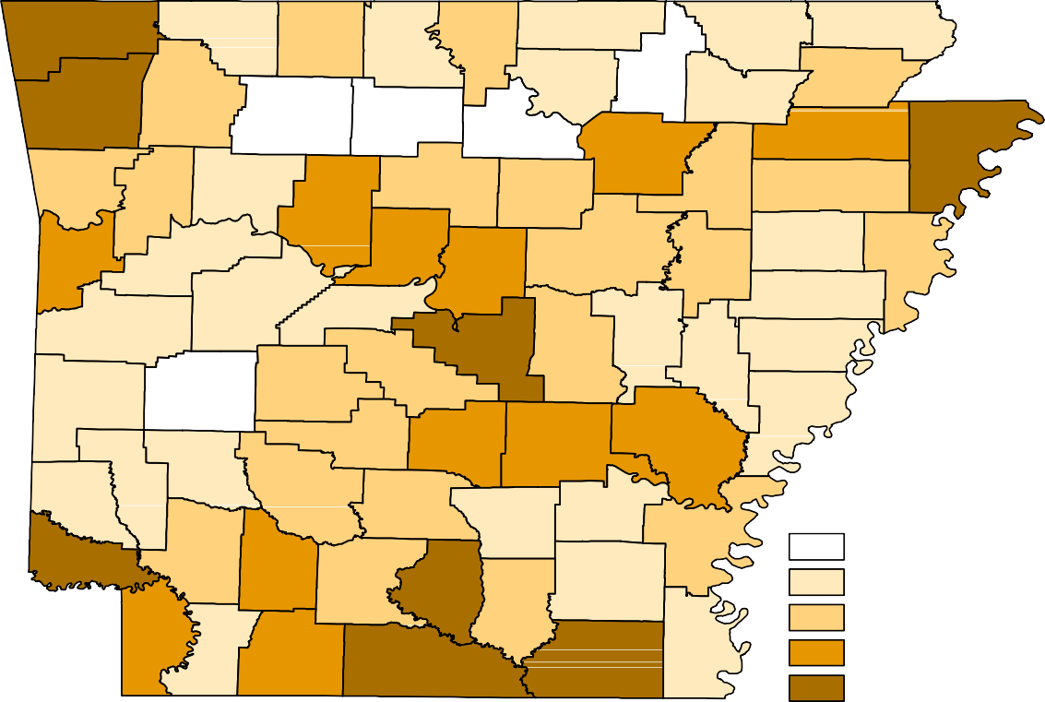
Benton
Carroll
Boone
Fulton
Clay
Marion
Baxter
Randolph
Sharp
Washington
Madison
Izard
Greene
Newton
Lawrence
Searcy
Stone
Craighead
Independence
Mississippi
Crawford
Franklin
Johnson
Van Buren
Cleburne
Jackson
Poinsett
Pope
Conway
Sebastian
Logan
White
Cross
Faulkner
Woodruff
Crittenden
Yell
Perry
St. Francis
Scott
Pulaski
Lonoke
Prairie
Lee
Saline
Monroe
Polk
Montgomery
Garland
Phillips
Hot Spring Grant
Jefferson
Arkansas
Sevier
Howard Pike
Clark
Dallas
Cleveland Lincoln
Desha
Little River
HempsteadNevada
Ouachita Calhoun
Drew
Miller
Bradley
LafayetteColumbia
Union
Ashley
Chicot
Annual Average Wages
< $30,000
$30,000 - $35,000
$35,000 - $40,000
$40,000 - $45,000
> $45,000

STATE OF ARKANSAS
Civilian Labor Force Summary
Labor force data, produced by the U.S. Department of Labor, Bureau of Labor Statistics and released by the Arkansas Division of Workforce Services, show Arkansas’ seasonally adjusted unemployment rate declined one and six-tenths of a percentage point, from 9.6 percent in May to 8.0 percent in June. May’s unemployment rate was revised up from 9.5 percent to 9.6 percent. Arkansas’ civilian labor force decreased 33,219 in June, a result of 9,297 fewer employed and 23,922 fewer unemployed Arkansans. The United States’ jobless rate decreased over two full percentage points, going from 13.3 percent in May to 11.1 percent in June.
BLS Program Operations Manager Susan Price said, “Despite moving into Phase 2 of reopening in June, there was a notable increase in the number of survey respondents in Arkansas reporting that they were not employed or had dropped out of the labor force. This was due in part to changes in seasonal sum- mer hiring trends and recent temporary layoffs/closures. These reported losses more than offset the hiring that occurred in June.”
Civilian Labor Force Estimates
Seasonally Adjusted
Not Seasonally Adjusted
Employment 1,206,952 1,216,249 1,312,004 Employment 1,220,232 1,222,416 1,322,546
Unemployment 105,338 129,260 48,367 Unemployment 109,561 127,087 56,737
Unemployment Rate 8.0 9.6 3.6 Unemployment Rate 8.2 9.4 4.1
U.S. Unemployment 11.1 13.3 3.7 U.S. Unemployment 11.2 13.0 3.8

 | Jun 20 | May 20 | Jun 19 | Jun 20 | May 20 | Jun 19
Civilian Labor Force | 1,312,290 | 1,345,509 | 1,360,371 Civilian Labor Force | 1,329,793 | 1,349,503 | 1,379,283

12.0%
Unemployment Rates - Arkansas vs United States (Seasonally Adjusted)
June: 2010 - 2020

10.0%

8.0%

6.0%

4.0%

2.0%

0.0%

2010 2011 2012 2013 2014 2015 2016 2017 2018 2019 2020
Arkansas United States

STATE OF ARKANSAS
Nonfarm Payroll Job Summary

Not Seasonally Adjusted
(In Thousands)

(NAICS) Jun 20 May 20 Jun 19 OTM OTY
Total Nonfarm | 1210.9 | 1192.4 | 1272.4 | 18.5 | -61.5
Goods Producing | 203.3 | 201.9 | 221.8 | 1.4 | -18.5
Mining, Logging, & Construction | 58.9 | 58.3 | 59.1 | 0.6 | -0.2
Mining & Logging | 5.1 | 5.1 | 6.0 | 0.0 | -0.9
Construction | 53.8 | 53.2 | 53.1 | 0.6 | 0.7
Specialty Trade Contractors | 33.9 | 33.4 | 33.6 | 0.5 | 0.3
Manufacturing | 144.4 | 143.6 | 162.7 | 0.8 | -18.3
Durable Goods | 64.4 | 63.3 | 78.1 | 1.1 | -13.7
Nondurable Goods | 80.0 | 80.3 | 84.6 | -0.3 | -4.6
Service Providing | 1007.6 | 990.5 | 1050.6 | 17.1 | -43.0
Trade, Transportation & Utilities | 254.2 | 246.6 | 251.4 | 7.6 | 2.8
Wholesale Trade | 48.8 | 48.2 | 47.8 | 0.6 | 1.0
Retail Trade | 135.8 | 129.0 | 136.0 | 6.8 | -0.2
Transport, Warehousing & Utilities | 69.6 | 69.4 | 67.6 | 0.2 | 2.0
Information | 10.2 | 10.3 | 11.5 | -0.1 | -1.3
Financial Activities | 60.9 | 61.1 | 63.0 | -0.2 | -2.1
Finance & Insurance | 47.7 | 48.0 | 48.9 | -0.3 | -1.2
Real Estate & Rental & Leasing | 13.2 | 13.1 | 14.1 | 0.1 | -0.9
Professional & Business Services | 141.5 | 139.4 | 143.7 | 2.1 | -2.2
Professional, Scientific & Technical | 43.8 | 43.5 | 44.4 | 0.3 | -0.6
Management of Companies | 35.6 | 35.1 | 33.6 | 0.5 | 2.0
Administrative & Support Services | 62.1 | 60.8 | 65.7 | 1.3 | -3.6
Educational & Health Services | 180.2 | 181.6 | 190.1 | -1.4 | -9.9
Educational Services | 13.5 | 14.1 | 13.0 | -0.6 | 0.5
Health Care & Social Assistance | 166.7 | 167.5 | 177.1 | -0.8 | -10.4
Ambulatory Health Care | 56.9 | 57.4 | 59.3 | -0.5 | -2.4
Social Assistance | 35.3 | 35.7 | 39.3 | -0.4 | -4.0
Leisure & Hospitality | 103.3 | 93.4 | 122.4 | 9.9 | -19.1
Arts, Entertainment & Recreation | 13.4 | 11.2 | 13.6 | 2.2 | -0.2
Accommodation & Food Services | 89.9 | 82.2 | 108.8 | 7.7 | -18.9
Accommodation Services | 7.9 | 7.6 | 12.1 | 0.3 | -4.2
Food Services | 82.0 | 74.6 | 96.7 | 7.4 | -14.7
Other Services | 57.1 | 54.8 | 60.1 | 2.3 | -3.0
Government | 200.2 | 203.3 | 208.4 | -3.1 | -8.2
Federal Government | 20.5 | 20.7 | 20.3 | -0.2 | 0.2
State Government | 70.9 | 74.3 | 74.6 | -3.4 | -3.7
State Gov, Educational Services | 23.3 | 26.6 | 26.7 | -3.3 | -3.4
State Gov, Excluding Education | 47.6 | 47.7 | 47.9 | -0.1 | -0.3
Local Government | 108.8 | 108.3 | 113.5 | 0.5 | -4.7
Local Gov, Educational Services | 66.7 | 66.6 | 67.4 | 0.1 | -0.7
Local Gov, Excluding Education | 42.1 | 41.7 | 46.1 | 0.4 | -4.0

STATE OF ARKANSAS
Nonfarm Payroll Job Summary

May 2020 - June 2020
Arkansas’ nonfarm payroll jobs rose 18,500 in June to total 1,210,900. Six major industry sectors posted gains, while employment in four sectors declined. Jobs in leisure and hospitality increased 9,900. Hir- ing occurred across all subsectors. Trade, transportation, and utilities added 7,600 jobs, mostly in retail trade (+6,800). Employment in other services rose 2,300. This sector includes businesses such as hair and nail salons, day spas, and membership organizations. Professional and business services increased 2,100. Gains were posted in all three subsectors. Jobs in government decreased 3,100. Most of the contractions were in state government, educational services (-3,300). Educational and health services declined 1,400. Small losses occurred in health care and social assistance (-800) and in edu- cational services (-600).
June 2019 - June 2020
Compared to June 2019, nonfarm payroll jobs in Arkansas are down 61,500. Losses were reported in nine major industry sectors, while two sectors added jobs. Jobs in leisure and hospitality declined 19,100. Most of the reduction was in accommodation and food services (-18,900). Jobs in manufac- turing decreased 18,300, largely due to durable goods manufacturing (-13,700). Employment in edu- cational and health services is down 9,900. All losses were posted in health care and social assistance (-10,400). Government jobs declined 8,200, with contractions in both local (-4,700) and state (-3,700) government. Smaller losses were reported in other services (-3,000), professional and business ser- vices (-2,200), financial activities (-2,100), information (-1,300), and mining and logging (-900). Em- ployment in trade, transportation, and utilities rose 2,800 over-the-year. Gains in transportation- warehousing-utilities (+2,000) and wholesale trade (+1,000) more than offset minor declines in retail trade (-200).

1,320,000

Nonfarm Payroll Jobs (Not Seasonally Adjusted)
January 2018 - June 2020

1,300,000

1,280,000

1,260,000

1,240,000

1,220,000

1,200,000

1,180,000

1,160,000

1,140,000

J F M A M J J A S O N D
2018 2019 2020

STATE OF ARKANSAS
Production Workers - Hours and Earnings

Manufacturing
Jun 19
43.7
18.68
812.82
May 20
38.0
18.24
693.12
Jun 20
Average Weekly Hours 39.2
Average Hourly Earnings 18.82
Average Weekly Earnings 737.74

Durable Goods and Nondurable Goods Manufacturing
Jun 19
45.0
17.02
765.90
May 20
38.7
16.88
653.26
Jun 20
Average Weekly Hours 39.6
Average Hourly Earnings 17.29
Average Weekly Earnings 684.68
Jun 19
42.2
20.50
865.10
May 20
37.2
20.09
747.35
Jun 20
Average Weekly Hours 38.8
Average Hourly Earnings 20.81
Average Weekly Earnings 807.43
Nondurable Goods Manufacturing
Durable Goods Manufacturing

$900.00

Average Weekly Earnings in Manufacturing (Production Workers)
June: 2010 - 2020

$800.00
$812.82

$700.00
$736.10
$737.74
$661.18
$650.87
$652.46
$660.19
$655.13
$636.32
$582.40
$571.73

$600.00

$500.00

$400.00

$300.00
2010 2011 2012 2013 2014 2015 2016 2017 2018 2019 2020

METROPOLITAN STATISTICAL AREAS
Little Rock - North Little Rock - Conway MSA
The Little Rock-North Little Rock-Conway MSA = Faulkner, Grant, Lonoke, Perry, Pulaski, & Saline counties.

Civilian Labor Force Estimates (Not Seasonally Adjusted)

 | Jun 20 | May 20 | Jun 19 | OTM | OTY
Civilian Labor Force | 349,070 | 354,363 | 362,917 | -5,293 | -13,847
Employment | 318,079 | 318,128 | 350,741 | -49 | -32,662
Unemployment | 30,991 | 36,235 | 12,176 | -5,244 | 18,815
Unemployment Rate | 8.9 | 10.2 | 3.4 | -1.3 | 5.5

Nonfarm Payroll Jobs (Not Seasonally Adjusted)
(In Thousands)

NAICS Jun 20 | May 20 | Jun 19 | OTM | OTY
Total Nonfarm 343.6 | 337.6 | 366.4 | 6.0 | -22.8
Goods Producing 37.4 | 36.9 | 39.4 | 0.5 | -2.0
Mining, Logging & Construction 18.2 | 17.9 | 17.9 | 0.3 | 0.3
Manufacturing 19.2 | 19.0 | 21.5 | 0.2 | -2.3
Service Providing 306.2 | 300.7 | 327.0 | 5.5 | -20.8
Trade, Transportation & Utilities 68.9 | 66.1 | 70.2 | 2.8 | -1.3
Wholesale Trade 15.6 | 15.5 | 15.8 | 0.1 | -0.2
Retail Trade 36.3 | 33.7 | 37.5 | 2.6 | -1.2
Trans., Warehousing & Utilities 17.0 | 16.9 | 16.9 | 0.1 | 0.1
Information 3.6 | 3.7 | 4.4 | -0.1 | -0.8
Financial Activities 20.9 | 20.9 | 22.1 | 0.0 | -1.2
Professional & Business Services 46.8 | 45.8 | 48.3 | 1.0 | -1.5
Educational & Health Services 52.4 | 52.8 | 57.5 | -0.4 | -5.1
Leisure & Hospitality 29.3 | 27.0 | 35.5 | 2.3 | -6.2
Other Services 17.6 | 17.2 | 18.8 | 0.4 | -1.2
Government 66.7 | 67.2 | 70.2 | -0.5 | -3.5
Federal Government 9.9 | 9.9 | 9.6 | 0.0 | 0.3
State Government 33.1 | 33.6 | 34.6 | -0.5 | -1.5
Local Government 23.7 | 23.7 | 26.0 | 0.0 | -2.3

Number of Unemployed
June 2018 - June 2020
45,000

Nonfarm Payroll Jobs
June: 2010 - 2020
370,000

40,000

35,000 360,000

30,000

25,000

350,000

20,000

15,000

340,000

10,000

330,000

5,000

www. discover.arkansas. gov
7
0
Jun '18 Dec '18 Jun '19 Dec '19 June '20

320,000

'10 '11 '12 '13 '14 '15 '16 '17 '18 '19 '20

METROPOLITAN STATISTICAL AREAS
Fayetteville - Springdale - Rogers MSA
The Fayetteville-Springdale-Rogers MSA = Benton, Madison, & Washington counties in Arkansas and McDonald county in Missouri.
Civilian Labor Force Estimates (Not Seasonally Adjusted)

 | Jun 20 | May 20 | Jun 19 | OTM | OTY
Civilian Labor Force | 273,583 | 277,485 | 280,387 | -3,902 | -6,804
Employment | 256,159 | 257,600 | 272,693 | -1,441 | -16,534
Unemployment | 17,424 | 19,885 | 7,694 | -2,461 | 9,730
Unemployment Rate | 6.4 | 7.2 | 2.7 | -0.8 | 3.7

Nonfarm Payroll Jobs (Not Seasonally Adjusted)
(In Thousands)

NAICS Jun 20 | May 20 | Jun 19 | OTM | OTY
Total Nonfarm 253.8 | 251.3 | 261.0 | 2.5 | -7.2
Goods Producing 40.9 | 40.8 | 42.6 | 0.1 | -1.7
Mining, Logging & Construction 12.4 | 12.2 | 12.5 | 0.2 | -0.1
Manufacturing 28.5 | 28.6 | 30.1 | -0.1 | -1.6
Service Providing 212.9 | 210.5 | 218.4 | 2.4 | -5.5
Trade, Transportation & Utilities 56.5 | 55.1 | 56.2 | 1.4 | 0.3
Wholesale Trade 12.3 | 12.2 | 12.2 | 0.1 | 0.1
Retail Trade 25.5 | 24.3 | 25.7 | 1.2 | -0.2
Trans., Warehousing & Utilities 18.7 | 18.6 | 18.3 | 0.1 | 0.4
Information 1.9 | 1.9 | 2.1 | 0.0 | -0.2
Financial Activities 8.2 | 8.2 | 8.3 | 0.0 | -0.1
Professional & Business Services 51.2 | 50.4 | 49.8 | 0.8 | 1.4
Educational & Health Services 26.9 | 27.1 | 29.0 | -0.2 | -2.1
Leisure & Hospitality 24.3 | 22.4 | 27.3 | 1.9 | -3.0
Other Services 9.1 | 9.1 | 9.7 | 0.0 | -0.6
Government 34.8 | 36.3 | 36.0 | -1.5 | -1.2
Federal Government 2.8 | 2.8 | 2.7 | 0.0 | 0.1
State Government 13.3 | 14.8 | 13.9 | -1.5 | -0.6
Local Government 18.7 | 18.7 | 19.4 | 0.0 | -0.7

Unemployment Rates
June: 2010 - 2020
8.0%

Jobs in Leisure and Hospitality
June 2018 - June 2020
40,000

7.0% 35,000

6.0%

30,000

5.0%

25,000

4.0%

20,000

3.0%

15,000

2.0%

10,000

1.0%

5,000

0.0%

'10 '11 '12 '13 '14 '15 '16 '17 '18 '19 '20 0
Jun '18 Dec '18 Jun '19 Dec '19 June '20

METROPOLITAN STATISTICAL AREAS
Fort Smith MSA
The Fort Smith MSA = Crawford & Sebastian counties in Arkansas & LeFlore & Sequoyah counties in Oklahoma.

Civilian Labor Force Estimates (Not Seasonally Adjusted)

 | Jun 20 | May 20 | Jun 19 | OTM | OTY
Civilian Labor Force | 115,429 | 119,688 | 120,421 | -4,259 | -4,992
Employment | 106,907 | 105,975 | 115,731 | 932 | -8,824
Unemployment | 8,522 | 13,713 | 4,690 | -5,191 | 3,832
Unemployment Rate | 7.4 | 11.5 | 3.9 | -4.1 | 3.5

Nonfarm Payroll Jobs (Not Seasonally Adjusted)
(In Thousands)

NAICS Jun 20 | May 20 | Jun 19 | OTM | OTY
Total Nonfarm 108.4 | 107.1 | 113.9 | 1.3 | -5.5
Goods Producing 22.0 | 21.8 | 23.5 | 0.2 | -1.5
Mining, Logging & Construction 5.8 | 5.6 | 6.2 | 0.2 | -0.4
Manufacturing 16.2 | 16.2 | 17.3 | 0.0 | -1.1
Service Providing 86.4 | 85.3 | 90.4 | 1.1 | -4.0
Trade, Transportation & Utilities 22.9 | 22.3 | 22.9 | 0.6 | 0.0
Wholesale Trade 4.2 | 4.2 | 4.2 | 0.0 | 0.0
Retail Trade 12.9 | 12.3 | 12.2 | 0.6 | 0.7
Trans., Warehousing & Utilities 5.8 | 5.8 | 6.5 | 0.0 | -0.7
Information 1.1 | 1.1 | 1.2 | 0.0 | -0.1
Financial Activities 4.2 | 4.2 | 4.0 | 0.0 | 0.2
Professional & Business Services 11.2 | 10.7 | 12.4 | 0.5 | -1.2
Educational & Health Services 16.6 | 16.7 | 17.5 | -0.1 | -0.9
Leisure & Hospitality 8.8 | 8.1 | 9.7 | 0.7 | -0.9
Other Services 4.2 | 4.2 | 4.6 | 0.0 | -0.4
Government 17.4 | 18.0 | 18.1 | -0.6 | -0.7
Federal Government 1.3 | 1.3 | 1.3 | 0.0 | 0.0
State Government 2.8 | 3.0 | 2.9 | -0.2 | -0.1
Local Government 13.3 | 13.7 | 13.9 | -0.4 | -0.6

Over-the-Year Change by Industry Sector
June 2019 vs June 2020

Financial Activities

Trade-Transport-Utilities

Information

Mining-Logging-Construction

Other Services

Government

Educational & Health

Leisure & Hospitality

Manufacturing

Professional & Business

-1,400 -1,200 -1,000 -800 -600 -400 -200 0 200 400

METROPOLITAN STATISTICAL AREAS
Hot Springs MSA
The Hot Springs MSA = Garland County.

Civilian Labor Force Estimates (Not Seasonally Adjusted)

 | Jun 20 | May 20 | Jun 19 | OTM | OTY
Civilian Labor Force | 41,374 | 42,090 | 41,985 | -716 | -611
Employment | 36,944 | 36,387 | 40,295 | 557 | -3,351
Unemployment | 4,430 | 5,703 | 1,690 | -1,273 | 2,740
Unemployment Rate | 10.7 | 13.5 | 4.0 | -2.8 | 6.7

Nonfarm Payroll Jobs (Not Seasonally Adjusted)
(In Thousands)
NAICS
Total Nonfarm Goods Producing Service Providing Government

Jun 20 | May 20 | Jun 19 | OTM | OTY
37.6 | 36.3 | 39.5 | 1.3 | -1.9
4.5 | 4.3 | 4.7 | 0.2 | -0.2
33.1 | 32.0 | 34.8 | 1.1 | -1.7
4.2 | 4.4 | 4.3 | -0.2 | -0.1

44,000

Number of Employed
January 2018 - June 2020

42,000

40,000

38,000

36,000

34,000

32,000

30,000

J F M A M J J A S O N D
2018 2019 2020

METROPOLITAN STATISTICAL AREAS
Jonesboro MSA
The Jonesboro MSA = Craighead & Poinsett counties.

Civilian Labor Force Estimates (Not Seasonally Adjusted)

 | Jun 20 | May 20 | Jun 19 | OTM | OTY
Civilian Labor Force | 64,898 | 66,262 | 66,185 | -1,364 | -1,287
Employment | 59,887 | 60,654 | 64,047 | -767 | -4,160
Unemployment | 5,011 | 5,608 | 2,138 | -597 | 2,873
Unemployment Rate | 7.7 | 8.5 | 3.2 | -0.8 | 4.5

Nonfarm Payroll Jobs (Not Seasonally Adjusted)
(In Thousands)
NAICS
Total Nonfarm Goods Producing Service Providing Government

Jun 20 | May 20 | Jun 19 | OTM | OTY
57.8 | 57.7 | 59.6 | 0.1 | -1.8
10.2 | 10.3 | 10.4 | -0.1 | -0.2
47.6 | 47.4 | 49.2 | 0.2 | -1.6
7.9 | 7.9 | 9.1 | 0.0 | -1.2

70,000

Jobs in Goods Producing and Service Providing Sectors
June: 2000 - 2020

Goods Producing + Service Providing = Total Nonfarm

60,000

50,000

40,000

30,000

20,000

10,000

0
'00 '02 '04 '06 '08 '10 '12 '14 '16 '18 '20
Goods Producing Service Providing

METROPOLITAN STATISTICAL AREAS
Pine Bluff MSA
The Pine Bluff MSA = Cleveland, Jefferson, & Lincoln counties.

Civilian Labor Force Estimates (Not Seasonally Adjusted)

 | Jun 20 | May 20 | Jun 19 | OTM | OTY
Civilian Labor Force | 34,233 | 34,637 | 35,190 | -404 | -957
Employment | 30,987 | 31,161 | 33,171 | -174 | -2,184
Unemployment | 3,246 | 3,476 | 2,019 | -230 | 1,227
Unemployment Rate | 9.5 | 10.0 | 5.7 | -0.5 | 3.8

Nonfarm Payroll Jobs (Not Seasonally Adjusted)
(In Thousands)
NAICS
Total Nonfarm Goods Producing Service Providing Government

Jun 20 | May 20 | Jun 19 | OTM | OTY
31.6 | 31.3 | 32.5 | 0.3 | -0.9
5.6 | 5.4 | 6.0 | 0.2 | -0.4
26.0 | 25.9 | 26.5 | 0.1 | -0.5
8.7 | 8.8 | 9.0 | -0.1 | -0.3

36,000

Nonfarm Payroll Jobs
June 2017 - June 2020

35,000

34,000

33,000

32,000

31,000

30,000

29,000

28,000
Jun '17 Dec '17 Jun '18 Dec '18 June '19 Dec '19 June '20

METROPOLITAN STATISTICAL AREAS
Out-of-State MSAs

Civilian Labor Force Estimates (Not Seasonally Adjusted)

Memphis, TN-MS-AR MSA

The Memphis, TN-MS-AR MSA = Fayette, Shelby, & Tipton counties in Tennessee; Benton, Desoto, Marshall, Tate, & Tunica counties in Mississippi; & Crittenden County in Arkansas.

 | Jun 20 | May 20 | Jun 19 | OTM | OTY
Civilian Labor Force | 620,350 | 623,761 | 651,549 | -3,411 | -31,199
Employment | 546,528 | 557,268 | 620,093 | -10,740 | -73,565
Unemployment | 73,822 | 66,493 | 31,456 | 7,329 | 42,366
Unemployment Rate | 11.9 | 10.7 | 4.8 | 1.2 | 7.1

Texarkana MSA
The Texarkana MSA= Bowie County in Texas & Little River & Miller counties in Arkansas.

 | Jun 20 | May 20 | Jun 19 | OTM | OTY
Civilian Labor Force | 64,271 | 63,156 | 66,014 | 1,115 | -1,743
Employment | 58,951 | 56,412 | 62,999 | 2,539 | -4,048
Unemployment | 5,320 | 6,744 | 3,015 | -1,424 | 2,305
Unemployment Rate | 8.3 | 10.7 | 4.6 | -2.4 | 3.7

Memphis MSA - Unemployment Rates
June: 2010 - 2020
14.0%

Texarkana MSA - Number of Employed
January 2018 - June 2020
68,000

12.0%

64,000

10.0%

60,000
8.0%

6.0%
56,000

4.0%
52,000

2.0%

www. discover.arkansas. gov
13

0.0%

'10

'11

'12

'13

'14

'15

'16

'17

'18

'19

'20

48,000 J F M A M J J A S O N D
2018 2019 2020

MICROPOLITAN STATISTICAL AREAS AND CITIES
Civilian Labor Force Estimates

Micropolitan Labor Force Estimates

4.3
4.4
7.5
5.0
5.6
5.6
3.3
6.0
4.3
5.1
4.0
4.1
3.9
4.9
4.6
405
733
1,330
634
909
471
646
392
588
471
571
691
789
1,829
1,553
9,074
15,981
16,467
11,925
15,186
7,884
19,137
6,089
13,218
8,715
13,673
15,979
19,468
35,475
32,402
June 2019
Emp Unemp Rate
CLF
9,479
16,714
17,797
12,559
16,095
8,355
19,783
6,481
13,806
9,186
14,244
16,670
20,257
37,304
33,955
8.9
8.7
14.8
7.9
11.9
12.0
8.3
13.6
7.5
9.0
9.0
9.8
9.7
8.2
9.1
847
1,451
2,641
944
1,872
982
1,609
857
982
829
1,247
1,588
1,933
3,000
3,050
8,718
15,171
15,200
10,980
13,845
7,212
17,666
5,426
12,097
8,381
12,567
14,678
18,098
33,774
30,293
Emp Unemp Rate
CLF
9,565
16,622
17,841
11,924
15,717
8,194
19,275
6,283
13,079
9,210
13,814
16,266
20,031
36,774
33,343
8.3
7.6
12.6
7.6
11.0
9.6
6.8
11.8
7.2
8.4
7.9
9.1
8.5
7.4
8.4
787
1,251
2,190
903
1,704
770
1,293
728
938
768
1,082
1,459
1,682
2,690
2,782
8,711
15,160
15,207
10,974
13,834
7,215
17,650
5,434
12,094
8,376
12,603
14,661
18,061
33,762
30,265
Not Seasonally Adjusted
May 2020
June 2020
Emp Unemp Rate
CLF
9,498
16,411
17,397
11,877
15,538
7,985
18,943
6,162
13,032
9,144
13,685
16,120
19,743
36,452
33,047
Micro Area
Arkadelphia Micro Batesville Micro Blytheville Micro Camden Micro
El Dorado Micro Forrest City Micro Harrison Micro
Helena-West Helena Micro Hope Micro
Magnolia Micro Malvern Micro Mountain Home Micro Paragould Micro Russellville Micro Searcy Micro

Arkadelphia Micro = Clark County Batesville Micro = Independence County Blytheville Micro = Mississippi County
Camden Micro = Calhoun & Ouachita counties El Dorado Micro = Union County
Forrest City Micro = St. Francis County Harrison Micro = Boone & Newton counties Helena-West Helena Micro = Phillips County Hope Micro = Hempstead & Nevada counties Magnolia Micro = Columbia County

City Labor Force Statistics
Malvern Micro = Hot Spring County Mountain Home Micro = Baxter County Paragould Micro = Greene County Russellville Micro = Pope & Yell counties Searcy Micro = White County

Not Seasonally Adjusted

June 2020 May 2020 June 2019

City CLF Emp Unemp
Rate
CLF Emp Unemp
Rate
CLF Emp Unemp
Rate

Bella Vista Benton Bentonville Blytheville Cabot Conway
El Dorado Fayetteville Fort Smith Hot Springs Jacksonville Jonesboro Little Rock
North Little Rock Paragould
Pine Bluff Rogers Russellville Searcy Sherwood Springdale Texarkana, AR Van Buren West Memphis
11,996
16,971
26,232
6,006
11,782
32,942
6,921
47,750
38,563
15,228
11,634
38,809
96,561
30,151
12,642
16,375
34,921
13,099
10,011
15,728
38,424
13,573
10,151
10,644
11,074
15,654
24,695
5,122
10,834
30,275
5,993
43,899
35,445
13,133
10,298
35,654
86,665
26,588
11,412
14,532
32,691
12,166
9,227
14,353
36,163
12,260
9,413
9,145
922
1,317
1,537
884
948
2,667
928
3,851
3,118
2,095
1,336
3,155
9,896
3,563
1,230
1,843
2,230
933
784
1,375
2,261
1,313
738
1,499
7.7
7.8
5.9
14.7
8.0
8.1
13.4
8.1
8.1
13.8
11.5
8.1
10.2
11.8
9.7
11.3
6.4
7.1
7.8
8.7
5.9
9.7
7.3
14.1
12,157
17,185
26,567
6,097
11,957
33,671
7,013
48,738
39,826
15,724
11,797
39,676
98,196
30,722
12,875
16,576
35,422
13,231
10,136
16,070
38,971
13,741
10,387
10,736
11,147
15,659
24,859
5,119
10,827
30,279
5,997
44,190
35,579
12,935
10,302
36,124
86,691
26,596
11,435
14,622
32,908
12,176
9,236
14,357
36,403
12,198
9,445
9,129
1,010
1,526
1,708
978
1,130
3,392
1,016
4,548
4,247
2,789
1,495
3,552
11,505
4,126
1,440
1,954
2,514
1,055
900
1,713
2,568
1,543
942
1,607
8.3
8.9
6.4
16.0
9.5
10.1
14.5
9.3
10.7
17.7
12.7
9.0
11.7
13.4
11.2
11.8
7.1
8.0
8.9
10.7
6.6
11.2
9.1
15.0
12,235
17,772
27,010
6,117
12,352
34,465
7,040
48,146
39,933
15,022
11,870
39,350
99,124
30,436
12,858
16,728
35,736
13,374
10,359
16,334
39,577
13,951
10,598
10,655
11,804
17,258
26,323
5,546
11,961
33,395
6,578
46,809
38,502
14,324
11,352
38,103
95,531
29,308
12,301
15,531
34,846
12,764
9,878
15,821
38,559
13,274
10,232
10,078
431
514
687
571
391
1,070
462
1,337
1,431
698
518
1,247
3,593
1,128
557
1,197
890
610
481
513
1,018
677
366
577
3.5
2.9
2.5
9.3
3.2
3.1
6.6
2.8
3.6
4.6
4.4
3.2
3.6
3.7
4.3
7.2
2.5
4.6
4.6
3.1
2.6
4.9
3.5
5.4

www. discover.arkansas. gov 14

COUNTY LABOR FORCE STATISTICS
Civilian Labor Force Estimates
Not Seasonally Adjusted
 |  | June 2020 |  |  | May 2020 |  |  | June 2019
County | CLF | Emp Unemp | Rate | CLF | Emp Unemp | Rate | CLF | Emp Unemp | Rate

Arkansas Ashley Baxter Benton Boone Bradley Calhoun Carroll Chicot Clark Clay Cleburne Cleveland Columbia Conway
Craighead Crawford Crittenden Cross Dallas Desha Drew Faulkner Franklin Fulton Garland Grant Greene Hempstead Hot Spring Howard
Independence Izard
Jackson Jefferson Johnson Lafayette Lawrence Lee Lincoln Little River Logan Lonoke Madison Marion Miller

9,094
7,327
16,120
133,646
15,712
4,329
2,347
12,481
3,122
9,498
5,411
8,939
3,117
9,144
8,081
54,931
26,098
21,115
7,168
2,681
5,191
7,534
60,005
7,308
4,914
41,374
8,018
19,743
9,476
13,685
5,362
16,411
4,808
5,457
27,316
9,919
2,401
6,774
2,674
3,800
5,411
8,205
33,005
7,086
6,510
19,549

8,579
6,494
14,661
125,204
14,634
4,003
2,191
11,560
2,697
8,711
4,960
8,092
2,880
8,376
7,425
50,648
24,212
18,656
6,643
2,478
4,716
6,881
55,437
6,755
4,560
36,944
7,435
18,061
8,837
12,603
5,017
15,160
4,277
4,937
24,596
9,114
2,167
6,205
2,419
3,511
4,977
7,430
30,479
6,715
5,954
17,842

515
833
1,459
8,442
1,078
326
156
921
425
787
451
847
237
768
656
4,283
1,886
2,459
525
203
475
653
4,568
553
354
4,430
583
1,682
639
1,082
345
1,251
531
520
2,720
805
234
569
255
289
434
775
2,526
371
556
1,707

5.7
11.4
9.1
6.3
6.9
7.5
6.6
7.4
13.6
8.3
8.3
9.5
7.6
8.4
8.1
7.8
7.2
11.6
7.3
7.6
9.2
8.7
7.6
7.6
7.2
10.7
7.3
8.5
6.7
7.9
6.4
7.6
11.0
9.5
10.0
8.1
9.7
8.4
9.5
7.6
8.0
9.4
7.7
5.2
8.5
8.7

9,042
7,407
16,266
135,561
15,999
4,355
2,341
12,755
3,101
9,565
5,426
9,195
3,158
9,210
8,187
56,130
26,688
21,308
7,262
2,690
5,203
7,614
61,155
7,560
4,911
42,090
8,046
20,031
9,525
13,814
5,372
16,622
4,860
5,442
27,660
10,190
2,410
6,828
2,700
3,819
5,419
8,453
33,265
7,150
6,585
19,730

8,572
6,493
14,678
126,034
14,651
3,996
2,188
11,564
2,688
8,718
4,949
8,098
2,890
8,381
7,428
51,315
24,293
18,623
6,636
2,479
4,705
6,875
55,445
6,760
4,563
36,387
7,429
18,098
8,836
12,567
5,010
15,171
4,280
4,926
24,748
9,116
2,164
6,221
2,410
3,523
4,951
7,432
30,460
6,739
5,963
17,752

470
914
1,588
9,527
1,348
359
153
1,191
413
847
477
1,097
268
829
759
4,815
2,395
2,685
626
211
498
739
5,710
800
348
5,703
617
1,933
689
1,247
362
1,451
580
516
2,912
1,074
246
607
290
296
468
1,021
2,805
411
622
1,978

5.2
12.3
9.8
7.0
8.4
8.2
6.5
9.3
13.3
8.9
8.8
11.9
8.5
9.0
9.3
8.6
9.0
12.6
8.6
7.8
9.6
9.7
9.3
10.6
7.1
13.5
7.7
9.7
7.2
9.0
6.7
8.7
11.9
9.5
10.5
10.5
10.2
8.9
10.7
7.8
8.6
12.1
8.4
5.7
9.4
10.0

9,531
7,989
16,670
137,247
16,381
4,603
2,504
13,079
3,352
9,479
5,787
9,590
3,227
9,186
8,467
55,875
27,291
21,634
7,622
2,902
5,483
7,857
63,109
7,604
5,181
41,985
8,494
20,257
10,074
14,244
5,758
16,714
4,927
5,907
27,984
10,478
2,502
6,748
2,832
3,979
5,625
8,737
34,743
7,413
6,870
20,214

9,238
7,533
15,979
133,457
15,854
4,402
2,388
12,701
3,116
9,074
5,492
9,175
3,099
8,715
8,062
54,127
26,319
20,560
7,298
2,751
5,210
7,423
61,150
7,315
4,968
40,295
8,201
19,468
9,663
13,673
5,550
15,981
4,628
5,489
26,287
9,874
2,380
6,437
2,704
3,785
5,380
8,345
33,649
7,219
6,593
19,318

293
456
691
3,790
527
201
116
378
236
405
295
415
128
471
405
1,748
972
1,074
324
151
273
434
1,959
289
213
1,690
293
789
411
571
208
733
299
418
1,697
604
122
311
128
194
245
392
1,094
194
277
896

3.1
5.7
4.1
2.8
3.2
4.4
4.6
2.9
7.0
4.3
5.1
4.3
4.0
5.1
4.8
3.1
3.6
5.0
4.3
5.2
5.0
5.5
3.1
3.8
4.1
4.0
3.4
3.9
4.1
4.0
3.6
4.4
6.1
7.1
6.1
5.8
4.9
4.6
4.5
4.9
4.4
4.5
3.1
2.6
4.0
4.4

(continued on Page 16)

COUNTY LABOR FORCE STATISTICS
Civilian Labor Force Estimates
(continued from Page 15)

Not Seasonally Adjusted

 |  | June 2020 |  |  | May 2020 |  |  | June 2019
County | CLF | Emp Unemp | Rate | CLF | Emp Unemp | Rate | CLF | Emp Unemp | Rate

Mississippi Monroe Montgomery Nevada Newton Ouachita Perry
Phillips Pike Poinsett Polk Pope Prairie Pulaski Randolph
St. Francis Saline Scott Searcy Sebastian Sevier Sharp Stone Union Van Buren
Washington White Woodruff Yell
17,397
2,686
2,795
3,556
3,231
9,530
4,036
6,162
4,125
9,967
7,817
28,339
3,478
187,273
7,247
7,985
56,733
4,191
2,806
55,436
5,299
5,686
4,570
15,538
5,617
122,230
33,047
2,605
8,113
15,207
2,435
2,540
3,257
3,016
8,783
3,744
5,434
3,805
9,239
7,169
26,168
3,197
168,357
6,680
7,215
52,627
3,941
2,570
51,078
4,915
5,144
4,139
13,834
5,106
114,238
30,265
2,403
7,594
2,190
251
255
299
215
747
292
728
320
728
648
2,171
281
18,916
567
770
4,106
250
236
4,358
384
542
431
1,704
511
7,992
2,782
202
519
12.6
9.3
9.1
8.4
6.7
7.8
7.2
11.8
7.8
7.3
8.3
7.7
8.1
10.1
7.8
9.6
7.2
6.0
8.4
7.9
7.2
9.5
9.4
11.0
9.1
6.5
8.4
7.8
6.4
17,841
2,655
2,806
3,554
3,276
9,583
4,091
6,283
4,171
10,132
7,900
28,635
3,439
190,432
7,306
8,194
57,374
4,195
2,846
57,280
5,289
5,730
4,583
15,717
5,720
124,285
33,343
2,601
8,139
15,200
2,429
2,523
3,261
3,015
8,792
3,742
5,426
3,800
9,339
7,164
26,189
3,191
168,408
6,681
7,212
52,644
3,934
2,574
51,272
4,911
5,150
4,132
13,845
5,108
114,997
30,293
2,394
7,585
2,641
226
283
293
261
791
349
857
371
793
736
2,446
248
22,024
625
982
4,730
261
272
6,008
378
580
451
1,872
612
9,288
3,050
207
554
14.8
8.5
10.1
8.2
8.0
8.3
8.5
13.6
8.9
7.8
9.3
8.5
7.2
11.6
8.6
12.0
8.2
6.2
9.6
10.5
7.1
10.1
9.8
11.9
10.7
7.5
9.1
8.0
6.8
17,797
2,799
3,109
3,732
3,402
10,055
4,332
6,481
4,418
10,310
8,183
28,918
3,610
192,483
7,399
8,355
59,756
4,389
3,159
57,505
5,522
5,877
4,863
16,095
5,907
125,099
33,955
2,801
8,386
16,467
2,663
2,977
3,555
3,283
9,537
4,141
6,089
4,248
9,920
7,831
27,454
3,452
185,580
7,069
7,884
58,020
4,241
3,024
55,484
5,251
5,556
4,628
15,186
5,624
121,812
32,402
2,648
8,021
1,330
136
132
177
119
518
191
392
170
390
352
1,464
158
6,903
330
471
1,736
148
135
2,021
271
321
235
909
283
3,287
1,553
153
365
7.5
4.9
4.2
4.7
3.5
5.2
4.4
6.0
3.8
3.8
4.3
5.1
4.4
3.6
4.5
5.6
2.9
3.4
4.3
3.5
4.9
5.5
4.8
5.6
4.8
2.6
4.6
5.5
4.4

County Labor Force Summary

Between May and June, unemployment rates declined in 66 of Arkansas’ 75 counties. Rates in
eight counties increased, while one county was unchanged. Jobless rates ranged from a low of
5.2 percent in Madison County to a high of 13.6 percent in Chicot County.
In June, sixty-four counties posted unemployment rates at or above seven percent. That is down from 69 counties at or above seven percent in May. Monthly jobless rate changes ranged from a decline of three percentage points in Frankin County to an increase of nine-tenths of a percent- age point in Prairie County.
Compared to June 2019, unemployment rates are up in all 75 Arkansas counties. Over-the-year gains ranged from as low as a two percentage point increase in Calhoun and Yell counties to as much as a six and seven-tenths of a percentage point rise in Garland County.

County Unemployment Rates
www. discover.arkansas. gov
17
Rate
8.7
8.7
9.1
9.1
9.1
9.2
9.3
9.4
9.4
9.5
9.5
9.5
9.5
9.6
9.7
10.0
10.1
10.7
11.0
11.0
11.4
11.6
11.8
12.6
13.6
Rank County
51 Drew
51 Miller
53 Baxter
53 Montgomery
53 Van Buren
- Desha
- Monroe
- Logan
58 Stone
60 Cleburne
60 Jackson
60 Lee
60 Sharp
- St. Francis
- Lafayette
- Jefferson
- Pulaski
- Garland
- Izard
69 Union
- Ashley
- Crittenden
- Phillips
- Mississippi
- Chicot
Rank County Rate
22 Independence 7.6
22 Lincoln 7.6
28 Lonoke 7.7
28 Pope 7.7
30 Craighead 7.8
30 Ouachita 7.8
30 Pike 7.8
30 Randolph 7.8
30 Woodruff 7.8
35 Hot Spring 7.9
35 Sebastian 7.9
- Little River 8.0
- Conway 8.1
38 Johnson 8.1
38 Prairie 8.1
41 Clark 8.3
41 Clay 8.3
41 Polk 8.3
44 Columbia 8.4
44 Lawrence 8.4
44 Nevada 8.4
44 Searcy 8.4
44 White 8.4
49 Greene 8.5
49 Marion 8.5
Rate
5.2
5.7
6.0
6.3
6.4
6.4
6.5
6.6
6.7
6.7
6.9
7.2
7.2
7.2
7.2
7.2
7.3
7.3
7.3
7.4
7.5
7.6
7.6
7.6
7.6
Rank County
- Madison
- Arkansas
- Scott
- Benton
- Howard
5 Yell
- Washington
- Calhoun
- Hempstead
9 Newton
- Boone
- Crawford
12 Fulton
12 Perry
12 Saline
12 Sevier
17 Cross
17 Grant
17 Poinsett
- Carroll
- Bradley
- Cleveland
22 Dallas
22 Faulkner
22 Franklin
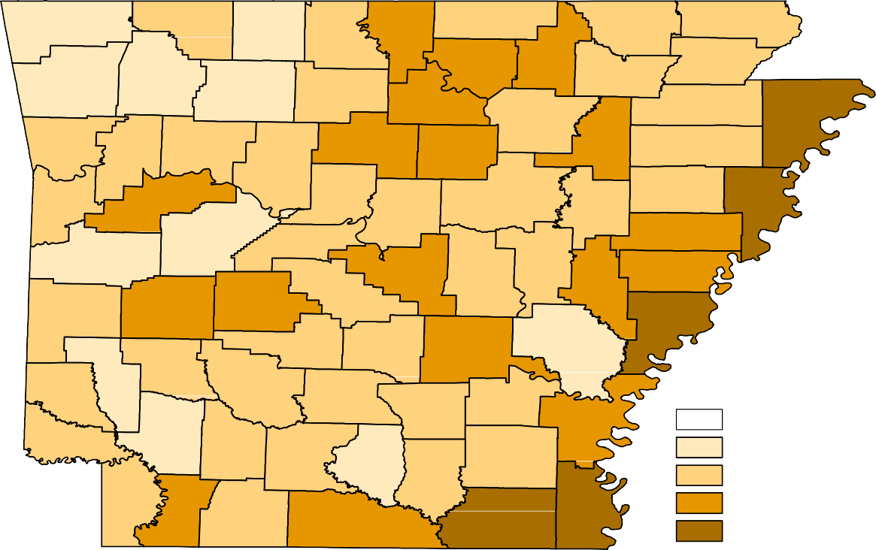
Benton
Carroll
Boone
Fulton
Clay
Marion
Baxter
Randolph
Sharp
Washington
Madison
Izard
Greene
Lawrence
Newton
Searcy
Stone
Independence
Craighead Mississippi
Crawford
Franklin
Johnson
Van Buren
Cleburne
Jackson
Poinsett
Pope
Sebastian
Logan
Conway
White
Cross
Faulkner
Woodruff
Crittenden
Yell
Perry
St. Francis
Scott
Pulaski
Lonoke
Prairie
Lee
Saline
Monroe
Polk
Montgomery
Garland
Phillips
Howard
Hot Spring Grant
Jefferson
Arkansas
Pike
Sevier
Clark
Dallas
Cleveland
Lincoln
Desha
Little River Hempstead Nevada Ouachita
Calhoun
Drew
Bradley
Miller Lafayette Columbia
Chicot
Union
Ashley
Unemployment Rates
< or = 5.0% [NONE] 5.1% - 7.0%
7.1% - 9.0%
9.1% - 11.0%
> 11.0%
Ranked by Unemployment Rates
June 2020 (Not Seasonally Adjusted)

LOCAL WORKFORCE DEVELOPMENT AREAS
Civilian Labor Force Estimates
257,376 248,983 8,393 3.3
99,124 95,531 3,593 3.6
46,924 44,535 2,389 5.1
95,722 91,099 4,623 4.8
124,173 118,980 5,193 4.2
329,320 319,922 9,398 2.9
82,499 78,294 4,205 5.1
94,169 89,674 4,495 4.8
133,816 127,819 5,997 4.5
113,709 109,535 4,174 3.7
250,124 225,886 24,238 9.7
98,196 86,691 11,505 11.7
45,747 40,307 5,440 11.9
93,007 84,115 8,892 9.6
123,694 111,803 11,891 9.6
324,723 300,215 24,508 7.5
79,405 71,919 7,486 9.4
90,840 82,570 8,270 9.1
131,688 118,055 13,633 10.4
112,076 100,855 11,221 10.0
20,752 8.4
9,896 10.2
4,737 10.5
7,971 8.7
10,470 8.6
21,270 6.7
7,056 8.9
7,620 8.4
11,317 8.7
8,470 7.8
Eastern 45,104 40,367
North Central 92,054 84,083
Northeast 121,470 111,000
Northwest 319,822 298,552
Southeast 78,848 71,792
Southwest 90,294 82,674
West Central 129,965 118,648
Western 109,055 100,585
Central (minus LR) 246,619 225,867
City of Little Rock 96,561 86,665
June 2019
CLF Emp Unemp Rate
Emp Unemp Rate
CLF
Not Seasonally Adjusted
May 2020
June 2020
Emp Unemp Rate
CLF
LWDA

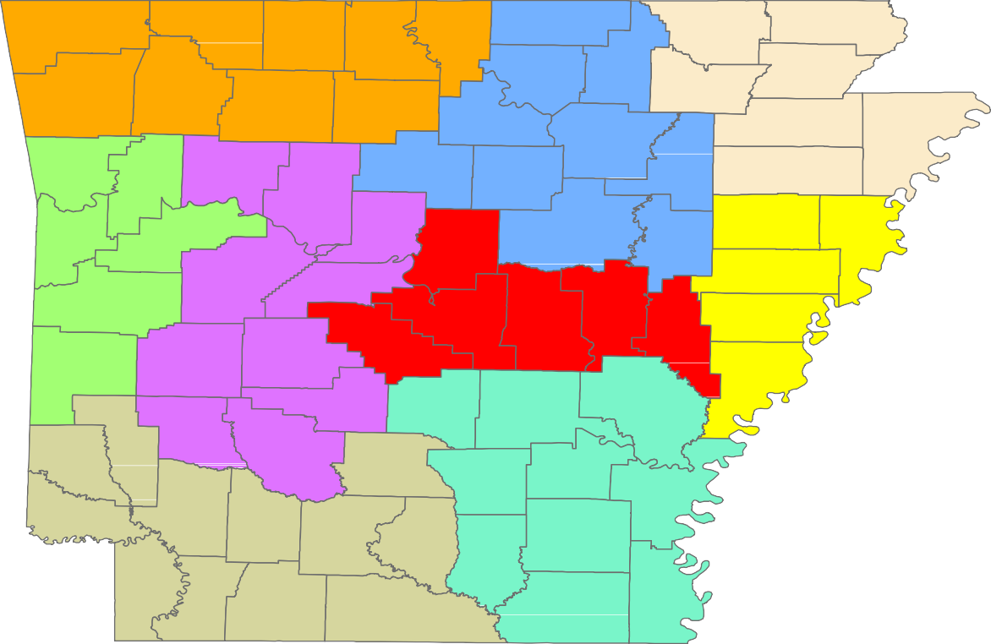
Benton
Carroll
Boone
Fulton
Clay
Marion
Baxter
Randolph
Sharp
Washington
Madison
Izard
Greene
Lawrence
Newton
Searcy
Stone
Craighead
Independence
Mississippi
Crawford
Jackson
Franklin
Johnson
Van Buren
Cleburne
Poinsett
Pope
Cross
Sebastian
Logan
Conway
White
Faulkner
Woodruff
Crittenden
Yell
Perry
St. Francis
Scott
Prairie
Pulaski Lonoke
Lee
Saline
Monroe
Polk
Montgomery
Garland
Phillips
Hot Spring
Grant
Jefferson
Arkansas
Howard
Pike
Sevier
Clark
Dallas
Cleveland
Lincoln
Desha
Little River Hempstead
Nevada
Ouachita
Calhoun
Drew
Bradley
Miller
Columbia
Chicot
Union
Ashley
Lafayette

Central (minus LR) Eastern
www. discover.arkansas. gov
18
North Central
Northeast Northwest Southeast
Southwest West Central Western

